

**BSc (Hons) Computer Science and Software**

**Engineering**

UNIVERSITY OF BEDFORDSHIRE

HireBuddy : Online Automobile Service Platform

**Submitted by:**

**1727525**

**Nuwantha Fernando**

Abstract

Visually impaired people in the world have been significantly increased during past few years. Therefore, they are unable to take advantage of many useful applications that average healthy people use daily. One such instant is the use of the calculator application of modern mobile devices to carry out day today calculations. Scan & Math has been developed as an Android application to address this issue by introducing a mechanism for the visually impaired people to carryout basic mathematic calculations just by scanning the numbers. Scan & Math combines several useful tools for visually impaired people such as the ability to scan any text and read them out loud. There are several similar applications in each mobile platforms providing some useful functionalities but none of them has the ability to offer them off-line or as a single package. To implement Scan & Math, OCR (Optical Character Recognition) technology has been used along with Text to speech, speech to text and web search technologies. The project has been implemented and tested using spiral methodology and the application has been given to several people with visual disabilities to refine the functions. Additional functionalities have been identified from the feedback such as the recognition of the hand written text and complex math functions and will be implemented in the future iterations. It’s expected that the visually impaired population will benefit from Scan & Math and their day today challenges will be a little less of a hassle.



i | P a g e

Acknowledgement

First and foremost, I want to express my sincere thanks to my supervisor Mr.Iresh Bandara and lecturer - in - charge Mrs.Gayana Fernando for their supervision throughout the project. Also, my heartfelt gratitude goes to Mr.Iresh Bandara for the encouragement and motivation given to me through the project.



ii | P a g e

Dedication

This thesis report is devoted to my father, who showed me that the best kind of knowledge to have is that which is erudite for its own sake. It is also devoted to my mother, who showed me that even the biggest task can be consummate if it is complete step by step.



iii | P a g e

Contents

|  |  |  |  |
| --- | --- | --- | --- |
| Abstract | .......................................................................................................................................................... | | i |
| Acknowledgement ........................................................................................................................................ | | | ii |
| Dedication .................................................................................................................................................... | | | iii |
| Chapter 01: Introduction .............................................................................................................................. | | | 1 |
| 1.1 | Project Background ....................................................................................................................... | | 1 |
| 1.2 | Aim and Objectives ....................................................................................................................... | | 2 |
| 1.3 | Project framework ........................................................................................................................ | | 3 |
| 1.4 | Structure of the report .................................................................................................................. | | 4 |
| Chapter 02: Literature Review ...................................................................................................................... | | | 6 |
| 2.1 | Introduction .................................................................................................................................. | | 6 |
| 2.2 | OCR technology applicable areas .................................................................................................. | | 6 |
| 2.3 | Text detection and recognition from an image ............................................................................ | | 8 |
| 2.4 | Design of OCR ................................................................................................................................ | | 9 |
| 2.5 | Text to speech ............................................................................................................................. | | 10 |
| 2.6 | Image filtering ............................................................................................................................. | | 11 |
| 2.7 | Symbol recognition in OCR base calculator ................................................................................ | | 12 |
| 2.8 | Similar applications ..................................................................................................................... | | 13 |
| 2.9 | Conclusion ................................................................................................................................... | | 16 |
| Chapter 03: Methodology ........................................................................................................................... | | | 17 |
| 3.1 | Introduction ................................................................................................................................ | | 17 |
| 3.2 | Requirement gathering and analysis .......................................................................................... | | 18 |
| 3.3 | Design .......................................................................................................................................... | | 21 |
| 3.3.1 | | Project plan ......................................................................................................................... | 22 |
| 3.3.2 | | Gantt chart .......................................................................................................................... | 23 |
| 3.3.3 | | WBS chart ............................................................................................................................ | 25 |
| 3.3.4 | | Interfaces Design ................................................................................................................. | 27 |
| 3.3.5 | | System Design ..................................................................................................................... | 29 |
| 3.4 | Implementation .......................................................................................................................... | | 33 |
| 3.5 | Testing ......................................................................................................................................... | | 46 |
| 3.6 | Evaluation ................................................................................................................................... | | 62 |
| Chapter 04: Results and Discussions ........................................................................................................... | | | 65 |



iv | P a g e

Chapter 05: Conclusion 66

5.1 Benefits 66

5.2 Limitations 67

5.3 Summery 67

5.5 Feature works 68

References 68

Appendix A - Interview Questions 74

Appendix B - Evaluation form 75

Appendix C - Poster 77



v | P a g e

Table of figures

Figure 1: Visually impaired per million population 2

Figure 2: Text detection and recognition process 8

Figure 3: Feature extraction process in detail 9

Figure 4: Detailed view of text to speech process 11

Figure 5: Image filtering methodes 12

Figure 6: Detailed comparison with currently existing products 15

Figure 7: Usage of smart devices for their health care 16

Figure 8: Graphical view of Spiral model 18

Figure 9: Process of requirement gathering 19

Figure 10:Daily engaging tasks 20

Figure 11: Total number of people 20

Figure 12:opinions about the system 21

Figure 13: GANTT chart 01 24

Figure 14: GANTT chart 02 24

Figure 15: GANTT chart 03 25

Figure 16: Work Breakdown Structure for the proposed project 26

Figure 17: Splash screen 27

Figure 18: Main interface 28

Figure 19: Interface with floating buttons 29

Figure 20:Usecase Diagram 30

Figure 21: Activity Diagram 31

Figure 22: Flow Diagram 32

Figure 23: graphical view of android platform 34

Figure 24: Code segment for import image from gallery 35

Figure 25: Code segment for capture image from camera 36

Figure 26: Result handling 37

Figure 27: process image to increase the quality 38

Figure 28:Correct the image orientation 38

Figure 29: Text recognition process 39

Figure 30: Recognized text set in to text view 40

Figure 31: Web search function 41

Figure 32: Calculation process 44

Figure 33: Text to speech 45

Figure 34:Speech to text 45

Figure 35: Testing methods 46

Figure 36:Performences of the application 63

Figure 37: Comments given by the users 64

Figure 38: Interview questions 74

Figure 39: Evaluation form part 1 75

Figure 40: Evaluation form part 2 76

Figure 41: Poster 77



vi | P a g e

Chapter 01: Introduction

1.1 Project Background

In today’s world, 253 million people of the world population has become visually impaired or has a condition related to eye sight mimicking (World Health Organization, 2018). People who are suffering eyesight issues fail to read letters and words as an ordinary person. This fact directly affects to reading difficulties and limitation of person's intellectual development. Therefore, it will be more helpful if they have a device or a software to assist them in the reading task. The technique that have been developed currently OCR (Optical Character Recognition) is a very strong solution for visually impaired people. Based on OCR techniques it is possible to develop an application to assist visually impaired people. By combining OCR and Text-to-Speech together will detect text from the image and convert that detected text in to voice as output. The application will divide into four main segments which are image processing, calculations, Speech-to-Text and Text-to-Speech processing.

This project mainly focuses to find a solution to help visually impaired people with their day-to-day tasks through a single android application. Like an ordinary application, ‘Scan & Math’ is not only for just to scan text from the image. For the user’s expediency it offers a bundle of features together. With the use of Scan & Math the user able to work out basic arithmetic equations by capturing an image of the specific equation. Application provides enlargeable output of the result and reads that particular output for the user. And also user can give voice inputs to the application if user required. Furthermore, this application allow user to specific scanned text search on the internet, if exhaustive information about the text is required by the user. It will be



1 | P a g e

more useful for people who thirst for knowledge. Likewise, the positive outcomes of this application will beneficial for the needy by increasing their efficiency and reducing the workload to do.

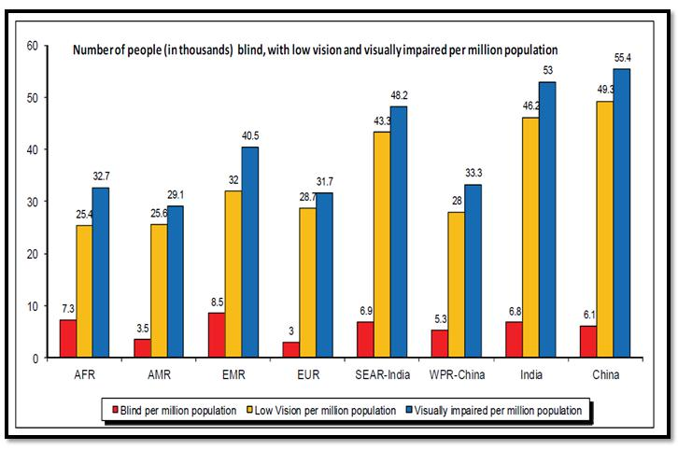

*Figure 1: Visually impaired per million population*

1.2 Aim and Objectives

**Aim**

Develop an android base application to aid visually impaired people in their day-to-day tasks.

**Objectives**

* To Identifying the key issues that visual impaired people face and provide all in one package for better use of an application.
* To Identifying the major OCR (Optical Character Recognition) and TTS (Text to Speech) technical methods.
* To Designing and developing the OCR application to detect text from the image and implement a method to solve different types of mathematical operations.



2 | P a g e

1.3 Project framework

Deep review of research papers, journals and articles determined the feasibility of the proposed project. As the commencing stage of this project, scope and the aim of this project were defined. In order to settle on the extent of the project, two types of information have been gathered. Basically primary data was collected through a questionnaire by conducting several interviews. It included questions regarding each person’s day-to-day tasks and performances while talking about their sentimentalities on this proposed system. As the secondary data, articles, journals, research papers, and case studies have been evaluated. Based on these evaluated data, a proper literature review was done to gain a clear idea about the research area. After gathering both primary and secondary data, the data were analyzed and the scope was finalized.

As the next stage of this project, planning was finalized by evaluating gathered information. Basically project planning, project objectives, and project deliverable were completed in this stage. After analyzing information gathered in the commencement stage, all the functions were recognized and unique functions were categorized according to the requirements, Later the project objectives and the schedule of the project were planned. After that the risk analysis was done according to the inspected and evaluated data. Spiral model was selected as the software development lifecycle model. Gantt chart are used to manage the time of this project. Before start developing the proposed system, work breakdown structure and the project breakdown structure were designed in order to get a basic idea about the entire framework. Both of these charts were used to manage time and cost of this entire system. Spiral model allows incremental release of the proposed project from time to time version vice. By following spiral model, the proposed project has been released time to time, version vice. Issuing this periodically, will be a



3 | P a g e

great chance to get user feedbacks about the application and additionally fix the errors in the current framework. Likewise, all of these will lead to increase the overall quality of the final product. This project was developed based on Object Oriented concepts and Android was elected to build the application. At last, the product has been tested under White-Box and Usability testing strategies before the evaluation.

1.4 Structure of the report

This is the final thesis report of “Scan&Math” application and it will consist of 5 main chapters as

below mention;

**Chapter 1: Introduction**

This is the foremost chapter of the thesis report and it will explain the project background, aim and the objectives, project framework and the structure of the report. The main responsibility of this chapter is to provide detail explanation about the project and the report.

**Chapter 2: Literature Review**

This is the second and the most valuable chapter in this report. It will provide a detail explanation about the researched areas which investigate to complete this product successfully. And also this section will provide a detail comparison between existing products and the Scan&Math (this project) to prove uniqueness and the accuracy.



4 | P a g e

**Chapter 3: Methodology**

This chapter will describe the development process by providing a detail explanation about the gathering requirements of the project. Designing phase of the project, implementation process, testing methods and the results, evaluation and last giving a brief idea about how the project was managed.

**Chapter 4: Results and discussion**

Chapter 4 is responsible for discuss the entire output of the project. It will give a brief idea about the accuracy and the performance of the system. Moreover, provide an explanation about technical problems which has occurred during the development process and how overcome them.

**Chapter 5: Conclusion**

As the final chapter of this report it will discuss about the entire project and the report. Basically this chapter provide detail explanation about the benefits and the limitations of the project. And also detailed summery of the project. Finally, it will be discussing future works of this system.



5 | P a g e

Chapter 02: Literature Review

2.1 Introduction

This chapter mainly focuses to identify and discusses the gravity of the topic OCR (Optical Character Recognition) technology as well as currently developed and researched areas about the OCR field. By exploring articles, academic journals, books and research papers identified new features which can add to this project. Identified new features, modern technologies and proper comparison between this application and the applications currently available in the market which have been more beneficial to increase the accuracy and the uniqueness of this project. By investigating different research papers and relevant articles helped to identify pros and cons of the OCR topic as well as possible challenges of this area. The importance of this chapter is to analytically evaluate the different strategies used in OCR field. With the facts, detected a suitable platform for examining the questionnaires and way to improve the uniqueness of the project.

2.2 OCR technology applicable areas

OCR (Optical Character Recognition) is a component which reading texts from graphical image with a software. With the use of this technology people are able to free from manual data entering. Text recognition system extracts texts from documents and insert in to database. Verma et.al (2016) clearly stated that presently this technology widely being used in many industries and following overview described some application areas of OCR.



6 | P a g e

**Banking**

OCR technology widely used in banking industry for cheque clearing without human involvement. By inserting cheque in to the machine, all features are scanned through the OCR and after successfully completion of scanning of the cheque that will be accepted. It is rarely required manual confirmation. This process more suitable for printed cheques and fairly effective in handwritten cheques as well. Overall, the result is efficient and reducing waiting times of the customer.

**Legal**

In legal industry, they are dealing with lots of paper based work. It will reduce space in the room. In order to free up space, they scan documents through OCR system and save them in computer database. So it is easy to search files in a computer rather than search it manually file by file in a filing cabinet.

**Healthcare**

In healthcare sector, it is possible to develop an application to scan images and extract the texts from the image. So, user is able to use that particular texts in any field as required. Basically this is more suitable for peoples with eyesight issues and others can efficient their tasks through OCR applications. And also this process can use in their paper works also. Normally Healthcare professionals deal with large volume of documents of patients. So with the use of OCR technology it is easy to create a digital database of documents and it is effective than a manual system.



7 | P a g e

2.3 Text detection and recognition from an image

The hidden concept of the OCR (Optical character Recognition) text detection and recognition from a graphical image is transforming the verbatim content in to ASCII value. The converted ASCII value can be used in various ways. According to the survey results conducted by Ye and Doermann (2015) have been stated that to recognize a text from an image, particular image must be converted in to string format. Such texts defined as” Structured edges”, “a sequence of identical color regions”, “a kind of texture” or “a collection of strokes”.

As per reference, Rizdania and Utaminingrum (2017) clearly described prior to the detection procedure of the content in the graphical image, particular image must be filtered through image processing mechanism. The inserting image must be transformed into 256 pixels for the shortest width or length, so the lengthier will have the reconciliation. This procedure is important and vital, so the application isn't overwhelming because of the large image sizes. Furthermore, Chandarana and Kapadia (2014) stated that OCR implemented through Matlab archived 92% of recognition rate and that rate higher than the recognition rate of ordinary OCR.

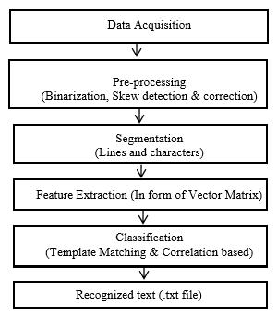

*Figure 2: Text detection and recognition process*



8 | P a g e

2.4 Design of OCR

There are different types of techniques available for design Optical Character Recognition system. Du et.al (2013) clearly stated that different types of techniques which are used to design OCR as below;

**Matrix matching:** Mostly known as pattern matching technique. Basically this approachtransform each and every character into a pattern which is locate inside a matrix. Afterwards it starts to compare the pattern with an index of identified characters. The accuracy and the recognition rate is high in mono typed and uniform single column pages.

**Fuzzy Logic:** This logic is multi-valued and enable transitional values to be characterized betweenconservative assessments like yes/no, true/false and so on. An attempts are more similar to the rational of a human than programming in PC. Fuzzy logic mostly applied when there is no distinct true or false value for the answers.

**Feature Extraction:** This strategy characterizes each character by the existence or inexistence ofmain features, including lines, width, density, height, loops, stems and other character qualities. Feature extraction is an ideal approach for laser print, OCR of magazines and excellent pictures.

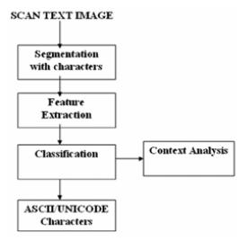

*Figure 3: Feature extraction process in detail*



9 | P a g e

**Structural analysis:** This approach identifies the character base on the sub features of an imagesuch as horizontal histograms, sub-vertical and shape of the graphical image. With that fact its’ character reparation ability perfect for low quality images.

**Neural Networks:** This system works more similar to human neural system. Once it received thepixels from image it will compare them with a known index of character pixel pattern. Therefore, this method more suitable for recognized text in damaged images.

2.5 Text to speech

With the help of OCR techniques, it is possible to detect the text from an image and after that recognized text translate into voice (speech). Aric et.al (2017) evidently expressed that Text to Speech could be a helpful component in various applications related to visually impaired and speech-enabled devices. Therefore, it helps peoples by reducing usage of visual interfaces.

Taylor (2009, p.77) observed that the Text to voice design contains set of modules related each other’s and the system has to continue the passing process one module to next module until the process complete. And also he explained that the ordinary systems use strings for the TTS design.

Translating text into a spoken wave form is the main task of the Text to voice system. Set of steps has to be complete to fulfill the task. Text Analysis, normalization form of the text, text processing, acoustic process and finally generating the speech. As the commencing stage of the process, text analysis is responsible for text sorting and arrange them into manageable list of words. After that sorted list of words filter through normalization and during this process all words are translate in to pronounceable form. This stage responsible for maintaining quality of the words, detect punctuation marks and pauses between words. Once the completion of



10 | P a g e

normalization, text prepared to process and it converts all the texts in to sequence of synthesis parts. Afterwards adding voices in to the texts through the acoustic processing stage. Finally, successfully completion of above stages, an acoustic waveform generates by speech generation and as the result words are out as speech.

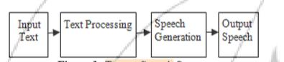

*Figure 4: Detailed view of text to speech process*

2.6 Image filtering

Zhang et.al (2012) has declared that the foggy, misty or hazy climatic conditions decrease the standard of a picture by reducing resolution and contrast of it. In order to make haze free image, this article proposing to enhance visibility of an image by use of novel effective algorithm. It clearly mentions that recognition rate of gray image or single color image higher than other types of images. In order to redraw fogless image, calculating the coefficient of normalized transmission with the dim channel previous. By the researched results, proved that proposed algorithm more easy and an effective method to enhance resolution and contrast of the misty image.



11 | P a g e

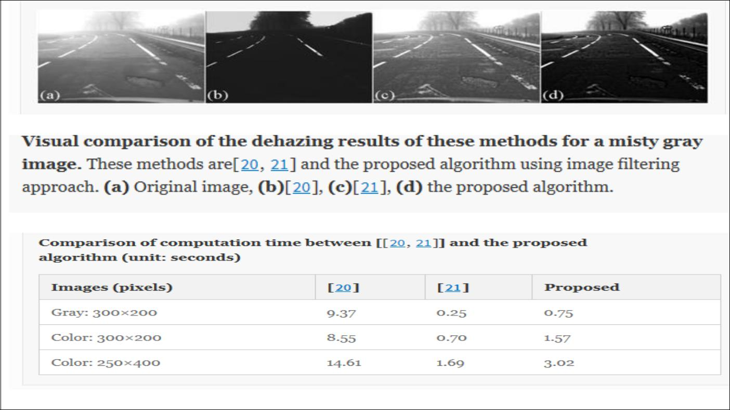

*Figure 5: Image filtering methodes*

2.7 Symbol recognition in OCR base calculator

Pranato et.al (2016) clearly stated that the structural analysis and the Symbol recognition are the two main steps in mathematical equation recognition. And also symbol recognition was identified as base of the structural analysis. Basically symbol recognition divide into two parts call segmentation and recognition. The inputs of the OCR (Optical Character Recognition) identified as set of strokes. Therefore, a mathematical symbol might contain multiple strokes. So the segmentation part responsible for the transforming strokes into a set of symbols and after particular symbol identified by symbol recognition stage. Basically neural network using for recognize symbol and to parse mathematical equation explicit syntactic use in structural analysis stage.



12 | P a g e

2.8 Similar applications

**Photomath**

Photomath is a OCR based android application which allows user to solve mathematical equations. It provides step by step instructions in a graphical way to solve the equation. Basically it helps user to understand the problem and teach to simplify similar type problems. Hamadneh and Al-Masaeed(2015) expressed that the application aims to solve mathematical equations through the mobile camera.

* Features
  + Able to detect hand written equations
  + Provide animated instructions
  + Simplify equations through the camera
* Limitations
  + Effective only with limited number of equation types.

**Photo calculator**

This application also developed to simplify mathematical equations through the mobile camera. OCR is the technology which is used to develop this application. For the user convenience it allows user to edit the detected equation if there is any difference with the actual equation.

* Features
  + Improved OCR system
  + Simplify equations through the camera



13 | P a g e

* Limitations
  + For some cases there is nothing to display after the scan.

**Text Scanner**

Text Scanner is OCR base application and it allows user to convert the graphical image into a text. It has inbuilt high speed reading methods and compatible with more than 50 languages all around the world.

* Features
  + Detect and recognize handwriting texts
* Limitations
  + Output fonts are very small and difficult to read.
  + Without the internet connection it doesn’t work.

**Text Fairy**

Text Fairy is an OCR base application which follows advanced image processing methods to detect text from the digital image. It allows user to edit the output and user can beneficial with text to speech function.

* Features
  + Detect and recognize handwriting texts
  + Compatible with more than 50 languages
  + Provide text to speech function.
* Limitations
  + Languages should be downloaded.



14 | P a g e

|  |  |  |  |  |  |  |  |  |  |
| --- | --- | --- | --- | --- | --- | --- | --- | --- | --- |
|  |  | Photomath | Photo | Text Scanner | Text Fairy |  | Scan | & |  |
|  |  |  | Calculator |  |  |  | Math(Proposed | |  |
|  |  |  |  |  |  |  | System) |  |  |
|  |  |  |  |  |  |  |  |  |  |
| Recognize the text | | **√** | **√** | **√** | **√** |  | **√** |  |  |
| from an Image |  |  |  |  |
|  |  |  |  |  |  |  |  |  |
|  |  |  |  |  |  |  |  |  |  |
| Text to voice |  | **-** | **-** | **-** | **√** |  | **√** |  |  |
|  |  |  |  |  |
|  |  |  |  |  |  |  |  |  |  |
| Simplify |  | **√** | **√** | **-** | **-** |  | **√** |  |  |
| mathematical |  |  |  |  |
|  |  |  |  |  |  |  |  |  |
| Calculations |  |  |  |  |  |  |  |  |  |
|  |  |  |  |  |  |  |  |  |  |
| Enlargeable | text | **-** | **-** | **-** | **√** |  | **√** |  |  |
| Output |  |  |  |  |
|  |  |  |  |  |  |  |  |  |
|  |  |  |  |  |  |  |  |  |  |
| Search on Web |  | **-** | **-** | **-** | **-** |  | **√** |  |  |
|  |  |  |  |  |
|  |  |  |  |  |  |  |  |  |  |
| Allow to edit | the | **√** | **√** | **√** | **-** |  | **√** |  |  |
| output |  |  |  |  |
|  |  |  |  |  |  |  |  |  |
|  |  |  |  |  |  |  |  |  |  |
| Voice Input |  | **-** | **-** | **-** | **-** |  | **√** |  |  |
|  |  |  |  |  |
|  |  |  |  |  |  |  |  |  |  |

*Figure 6: Detailed comparison with currently existing products*

Above figure 6 comparing the functionalities between currently available systems and the proposed system (Scan&Math). With this examination it will give a detailed explanation regarding distinctive functionalities of existing systems and proposed system while highlighting the exclusive functionalities offered by the proposed system.



15 | P a g e

2.9 Conclusion

In conclusion with the proofs delivered, utilizing Scan&Math offers useful and productive results to the user. It benefits users in various ways in their day today tasks. This review has described some OCR (Optical Character Recognition) techniques related to this project. Different types of applications related to this project and techniques have been carefully researched and studied to develop this application effectively. Most of existing applications are inefficiency because of utilizing old libraries and algorithms to their products. But with this application, it has been applied latest Google API libraries to increase performance and effectiveness of the application. As well as this product provides package of unique features like OCR web search and voice output in mathematical calculations for the users’ convenience. Likewise, this application offering attractive unique features to user as benefits. In addition, this application will upgrade to detect and recognize handwritten texts as future developments and adding surface view to capture customize area from camera. By adding these features in futures will be more beneficial to the users in their day-to-day tasks.

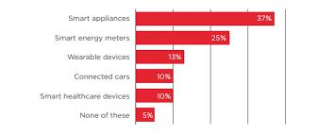

*Figure 7: Usage of smart devices for their health care*



16 | P a g e

Chapter 03: Methodology

3.1 Introduction

A Methodology consists of set of stages and directives to develop a successful product. In order to develop this project, as the methodology, Spiral model has been elected from Software Development Life Cycle (SDLC) models. According to the elected software development life cycle, all the project documents, analyzed requirements, Software design, implementation, testing and the evaluation has been completed.

Since the proposed system released version wise, spiral methodology was more appropriate and lead the way to successfully reach of the final artefacts of the proposed system. In this system each versions of spiral model began with design goal and discussed the evolution with the supervisor. It has been great opportunity to add more functionalities to the system until it is ready to release final version of this product. As the methodology, Spiral model has been beneficial this product be popular among the users and minimize the development risk. Since the product released version wise, it was great opportunity to gather feedback from the actual users and debugged them in advance versions of the product. Likewise, combination of all these features in spiral model has been helpful to develop reliable, effective, user friendly, high quality and bugs free final product.



17 | P a g e

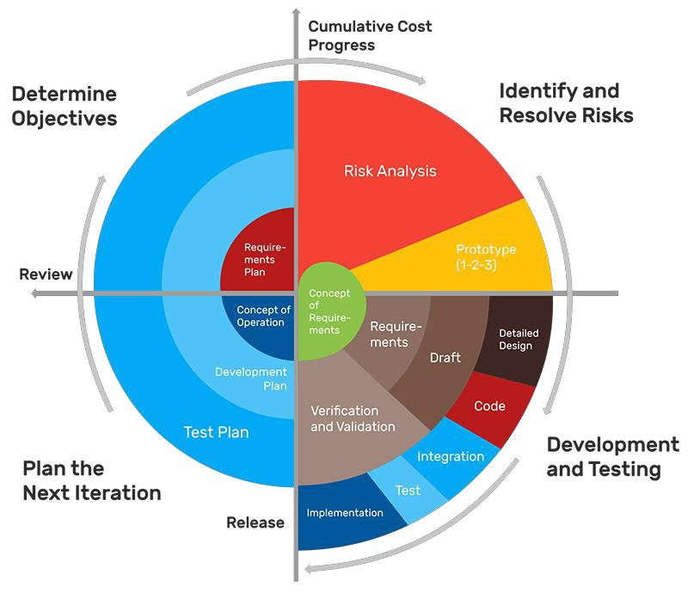

*Figure 8: Graphical view of Spiral model*

3.2 Requirement gathering and analysis

Requirement gathering is the most responsible stage of a software life cycle. Therefore, Requirement gathering phase has been the key point to this project. Since this project mainly focuses on visually impaired people, the system has been developed based on opinion and difficulties which visually impaired people faced in their day-to-day life. Number of interviews has been conducted with people who has eyesight issues, to gather fresh and actual requirements for this project. Based on their career and the background, tasks they engage day-to-day were different from person to person. However, it has been identified some tasks like reading, basic calculations etc. were common among each other. Collected data through interviews as primary data and some secondary data collected through literature review done by



18 | P a g e

accessing articles, research papers and journals. According to the literature review, got a clear idea about background and feasibility of the system. Finally, collected data analyzed according to their value and priority of the information while removing inconsistent and ambiguous requirements.

Interview questions can be found on Appendix B.

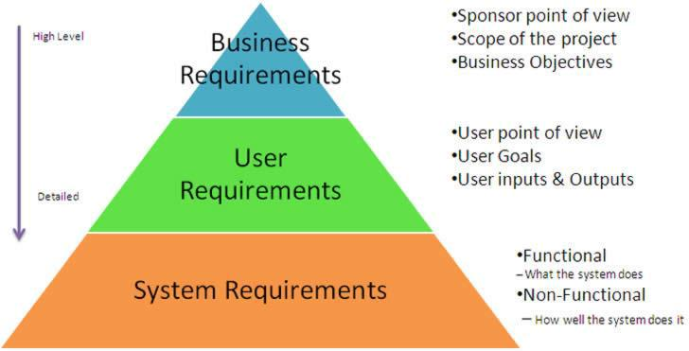

*Figure 9: Process of requirement gathering*

According to the interviews that have been conducted, analyzed the answers and opinions of all the 40 people. With that information it has been prepared the charts to gain clear idea about the visually impaired person’s needs. Below chart will demonstrate the common tasks which they are engaging daily.



19 | P a g e

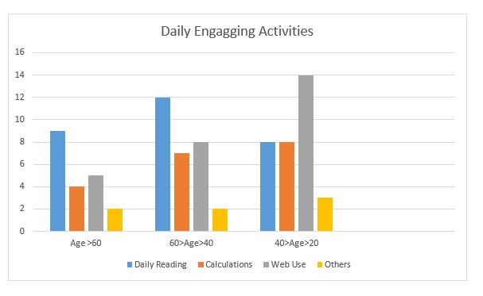

*Figure 10:Daily engaging tasks*

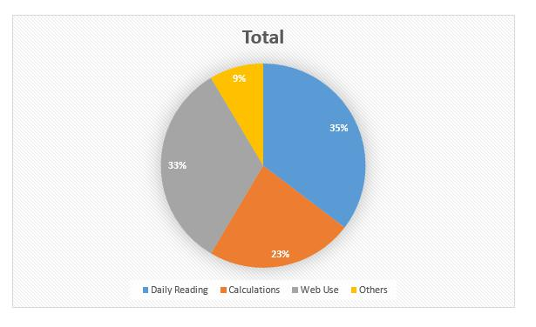

*Figure 11: Total number of people*



20 | P a g e

According to the view of interviewee, 5% of them were doesn’t agreed with the system because they believe they can manage their tasks by their own, 8% had no idea about the concept because majority of them doesn’t use mobile phones and they were too old. But 87% of the interviewees agreed with the system and they believe Scan&Math will be a successful application in the future. And also they really happy with that concept and thankful to concern about the visually impaired people. Following figure will portray the view of interviewees.

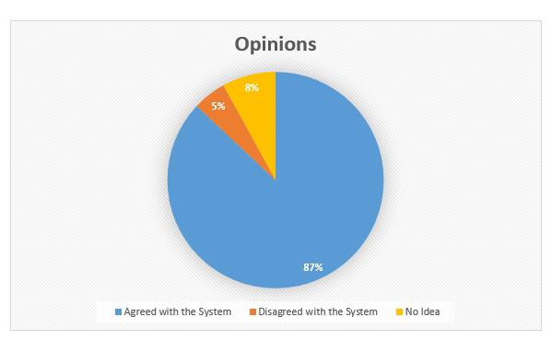

*Figure 12:opinions about the system*

3.3 Design

Design phase is the second stage of the Life cycle and each and every analyzed data from requirement gathering phase has been sent to this stage. Design phase is known as the



21 | P a g e

transformation phase because this is the stage that converts the concepts and requirements of the project into an actual working system. Since all features are worked by the design plan of the project, Design phase has more responsibilities to maintain software life line. According to the analyzed information which was received from requirements gathering phase Gantt chart, work breakdown structure, Project breakdown structure, use case diagrams and interfaces are designed for the managing and organizing purposes of the project.

Well planned design models always reduce the complexity and the risk of the project. Design plan always guiding to smooth development process of the system. Through the implementation process of functional implementations, design models guided the correct path to develop the functions more accurately. It was very easy to manage the time and reduce the risk of the project since the design models could identify the mistake or the errors occurring during the implementation.

3.3.1 Project plan

Proper project plan has always been a key factor to implement a high quality product. By linking all ideas and requirements together, it helps construct the way to reach final artefact or the system successfully. Without a suitable plan it is very difficult to complete each and every objectives of the project before deadline. Key objective should be planning artefacts, it is similar to a blueprint of the project and entire system builds on it. Therefore, artefacts need to be well planned and it will lead to keep project flow smooth.



22 | P a g e

The project plan was designed before the actual start of the work on the project. And it was successfully design according to Gantt chart. In addition, work breakdown structure was designed to get a clear view about the proposed system. So that it is easy to manage every functions in the proposed system. Work breakdown structure was designed according to the software life cycle model that has been chosen, which was spiral model. It was used to breakdown the workload and analyze the scope of the proposed system, so it was beneficial to fulfill responsibilities in a good manner and map all functionalities that have to be completed under the project.

3.3.2 Gantt chart

The Gantt chart has been designed to signify the timelines and the milestones of the project. With a well-designed Gantt chart, it is easy to manage time of this project and discuss each and every tasks through their achievements with the supervisor. Below figures portray a brief review of the vital begin and end dates of this project. All processes and tasks were planned as per the Gantt chart.



23 | P a g e

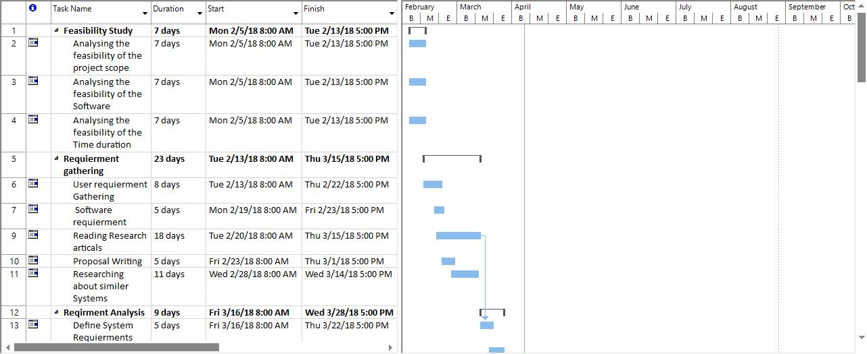

*Figure 13: GANTT chart 01*

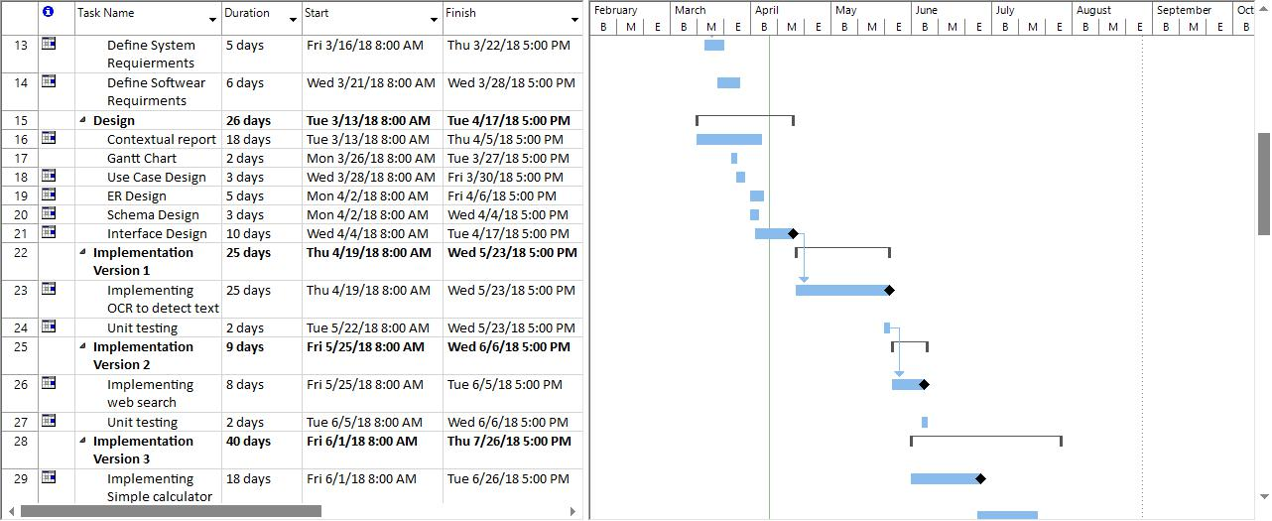

*Figure 14: GANTT chart 02*



24 | P a g e

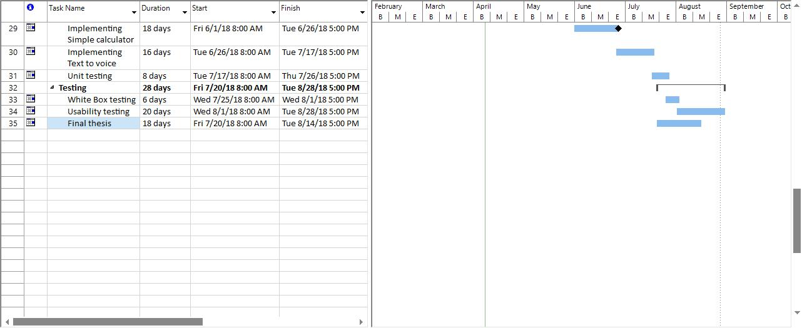

*Figure 15: GANTT chart 03*

3.3.3 WBS chart

Work break down structure is a key to arrange work into manageable segments. According to its graphical perspective, the works have been completed to successfully achieve final output of this project. And furthermore each level of work breakdown structure offers work to be completed in detailed view and it was really helped to monitor the workflow of this project. It acts like a map or an outline of the project. By utilization of the work breakdown Structure can simply analyze project time and the budget while classifying possible risks of this project.



25 | P a g e

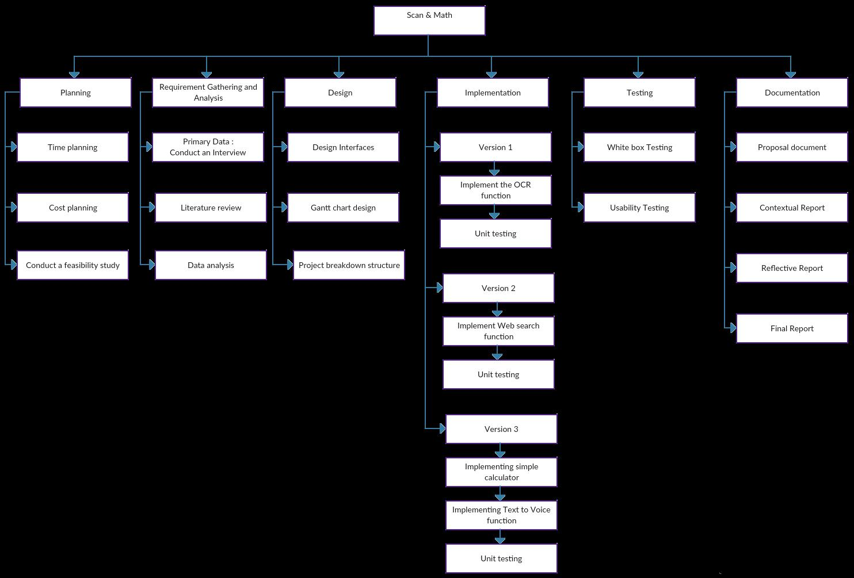

*Figure 16: Work Breakdown Structure for the proposed project*



26 | P a g e

3.3.4 Interfaces Design

Interfaces of this application were designed in a user friendly manner. It will not be overwhelming to the new users. Since this application will be generally used by visually impaired peoples, the interfaces must be more simplistic and friendly to the user. And also it will encourage other peoples to utilize this application in their day -to-day tasks. The first interface which will be displayed to the user is the welcome screen with the application name and the splashing application icon. After that it proceeds to a very simplistic interface which contains a large text area and a floating button. When user touches on this floating button other sub buttons will appear according to designed animation, otherwise all sub buttons are invisible. Use of this “floating button” concept will free up more space for content view.

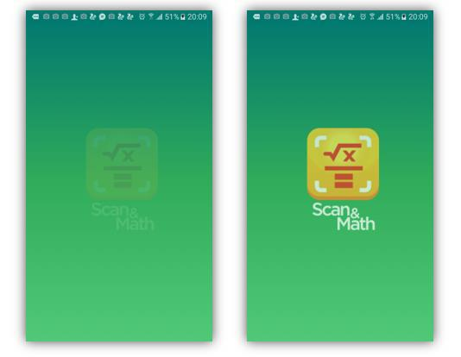

*Figure 17: Splash screen*



27 | P a g e

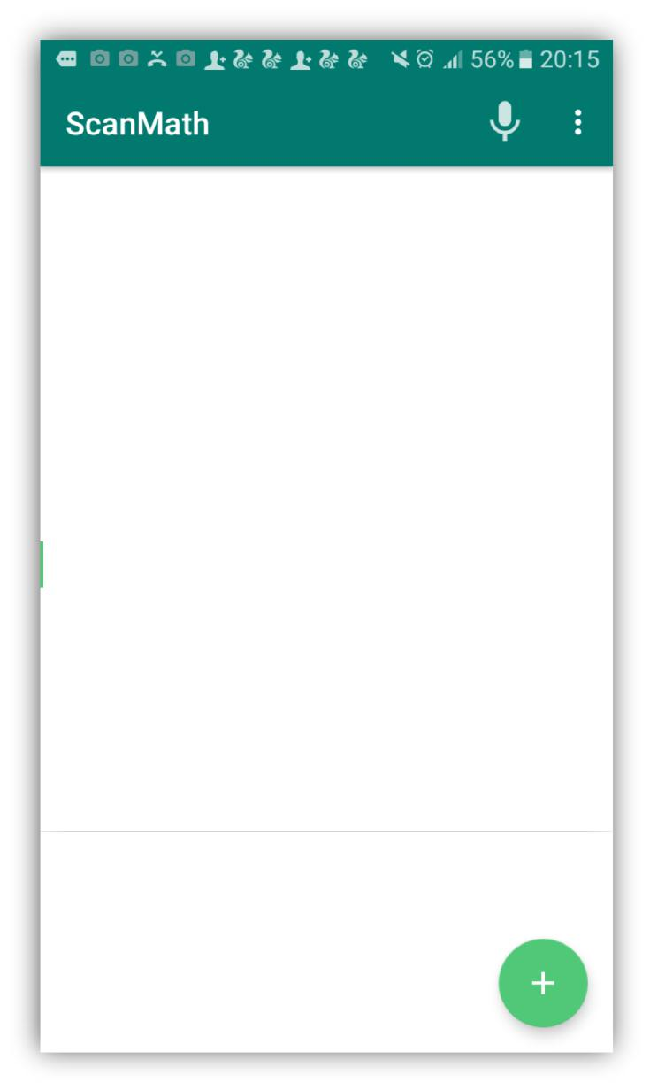

*Figure 18: Main interface*



28 | P a g e

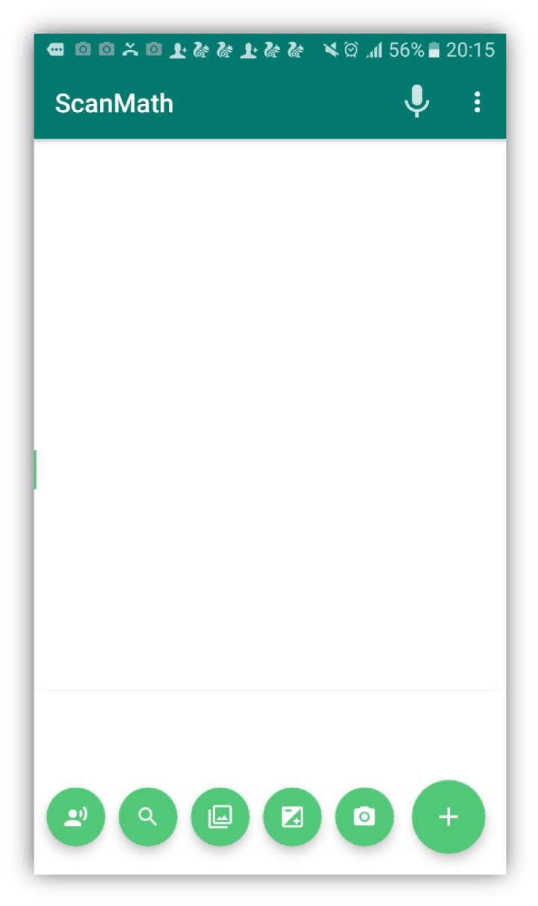

*Figure 19: Interface with floating buttons*

3.3.5 System Design

**Use Case Diagram**

Use case diagram designed for describe functionalities of the system. It is help to specify a desired behavior of the proposed system and identify communication between system and the external entities. In this system User is an external entity and User can interact with the system through Capture/Upload an image, Search detected text on web, Read detected text and simple



29 | P a g e

calculating tasks. Once the user done with capture or upload image, system proceed with text detection and recognize task from the image. Following figure will demonstrate interaction of each and every actions which related to this system and how it communicates with the external entities.

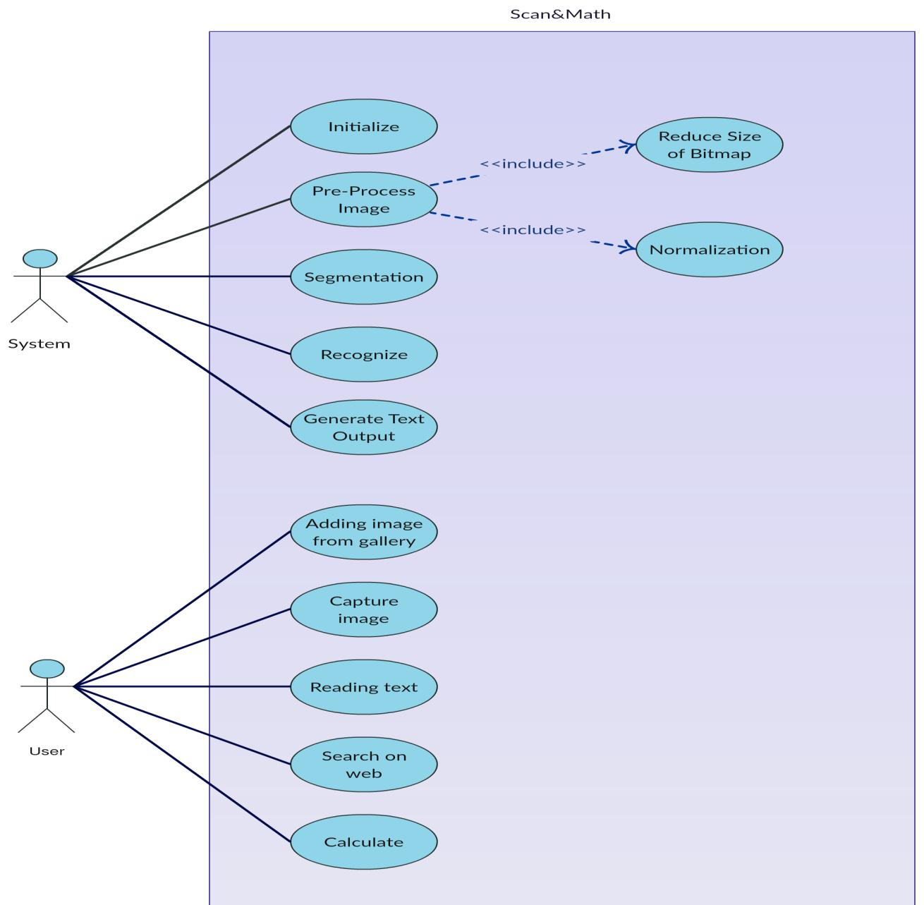

*Figure 20:Usecase Diagram*



30 | P a g e

**Activity Diagram and Flow Chart**

After identifying functionalities of the system, activity diagram has been designed to analyze system functionalities and identify uses cases of the system. With that fact it was helped to study individual use cases in detail and identify concurrency issues of the system. Following figures will describe the activity diagram and the flow chart of the system.

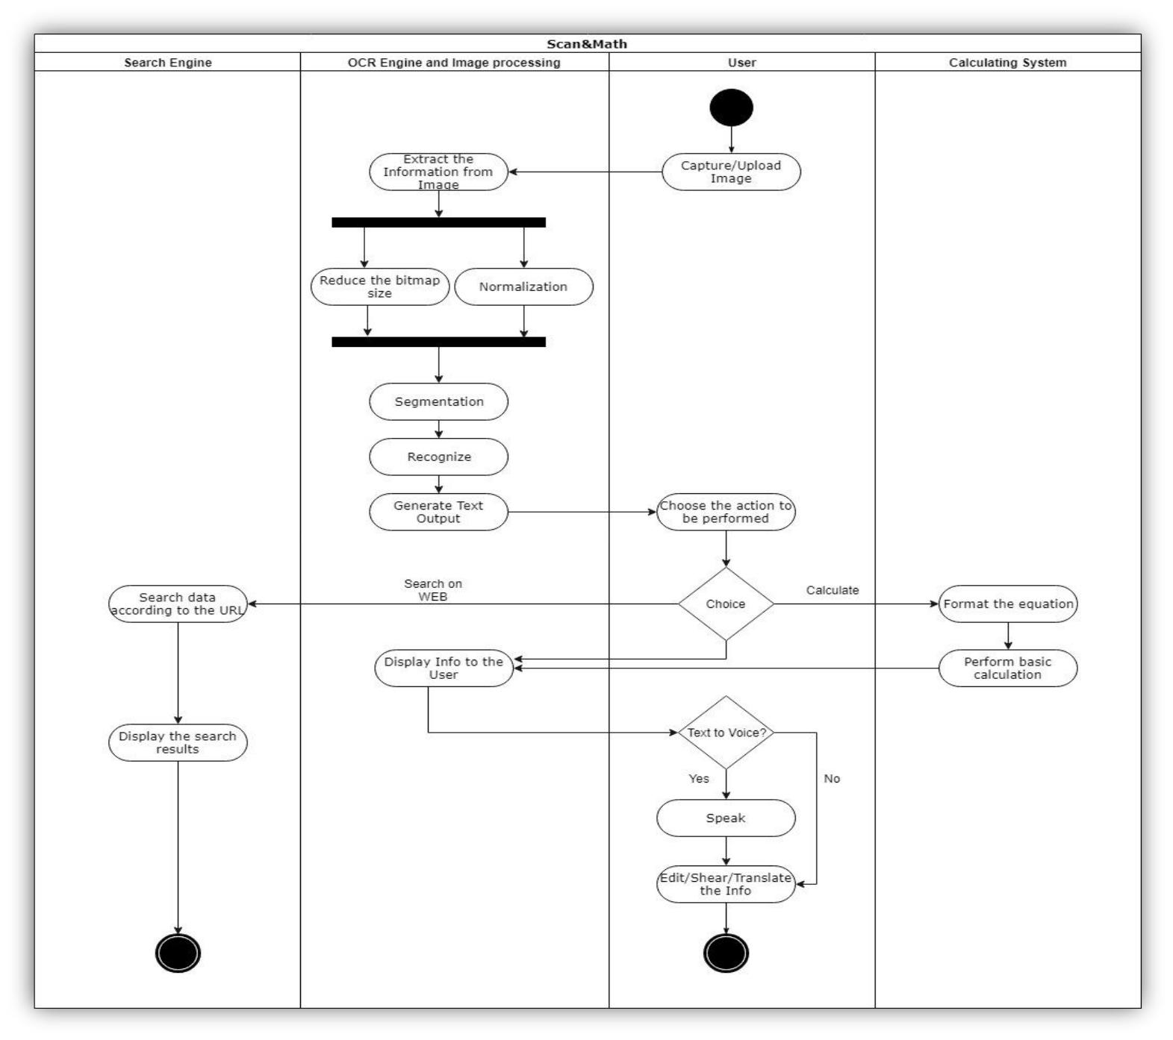

*Figure 21: Activity Diagram*



31 | P a g e

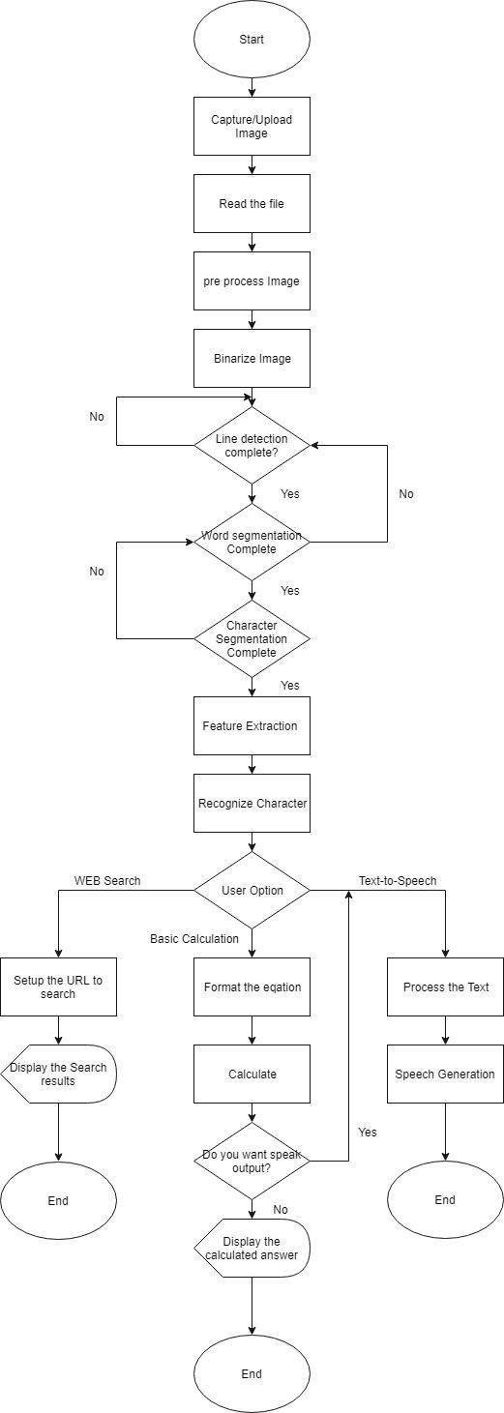

*Figure 22: Flow Diagram*



32 | P a g e

3.4 Implementation

This is the phase where the analyzed requirements deployed into proposed working system. According to the GANTT chart time line and the design plan, implementation process has been completed. Step by step reach to the aim of the project by coding each and every tasks of the system. Since the application based on android environment, it has been used Android Studio to develop the project. Product was released time to time version vise under spiral model life cycle. Object Oriented Principals were used in proper manner to complete coding tasks in each version. And also it was helped to maintain quality of the code and increase efficiency of the system. Mainly Google API library used to recognize detected text from the image and some other java and android libraries used to maintain quality of the product. Other additional technologies used as follows;

* **Java language**

Java language used in suitable manner since the application based on class-oriented and object-oriented. And also it has been helped to manage entire coding segments and the efficiency of the system.

* **Android Studio**

Android Studio is the IDE which was used to code this mobile application through java language. And also this is the official IDE for the android application developments which will provides smooth service to the developer.



33 | P a g e

* **Android platform**

The main reason to select Android as the platform is, it is high accuracy open source platform. And also it is easy to popular in the market, since most of the peoples were using android base smart phones.

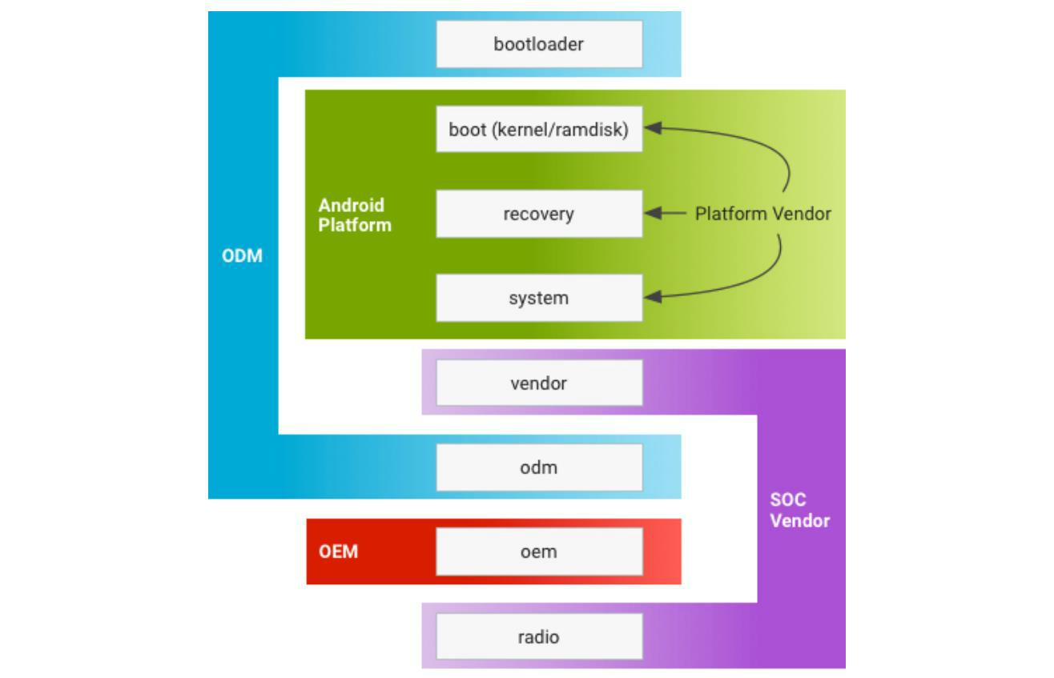

*Figure 23: graphical view of android platform*

Proposed project released version vise and every new version built according to the user feedbacks and fixed bugs for the users’ convenience. Up to now this project released 3 versions of this application and detailed implementations of each versions as bellows;



34 | P a g e

**Version 1**

This is the very first version of the application and mainly this version aimed to popular within the users by giving basic idea about the application. As the commenced version of this application, it has provided text detection function only. So it was a great opportunity to users’ check the uniqueness and effectiveness of this system.

* Detect text from digital image.
* Unit Tested.

**Implementation**

* **Select Image from gallery**

Following figure describes the selecting image from gallery and it will start the activity soon after all intent details setting completed.

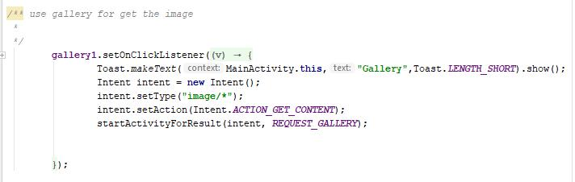

*Figure 24: Code segment for import image from gallery*



35 | P a g e

* **Capture image and save**

Before the capture an image there should be a file to save that captured image. For that it will create a file with current date time and save it in default storage. After that particular image file send to the camera event and it will extract the image uri from the image file. Finally, camera is ready to capture image and it will start the activity to capture image. Following figures will demonstrate the coding of image capturing process.

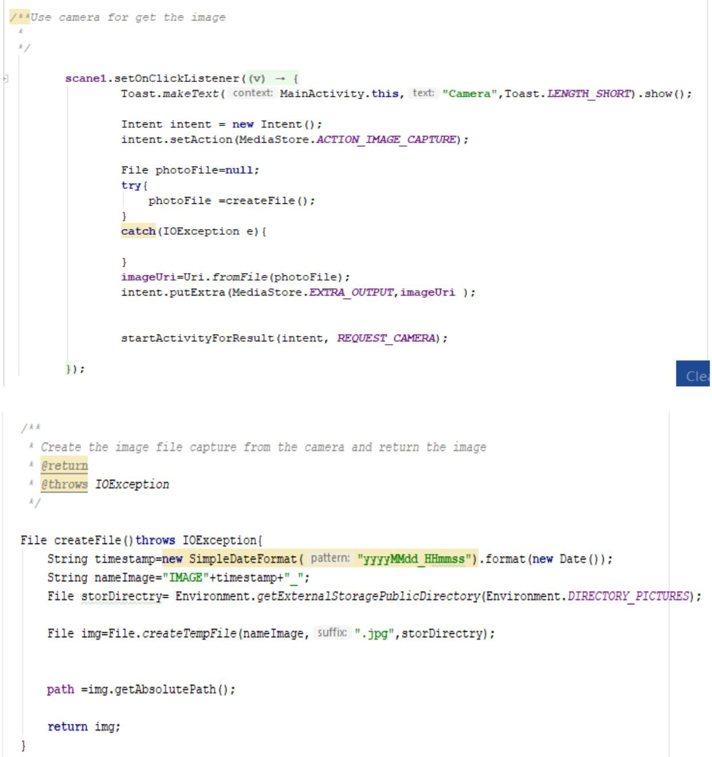

*Figure 25: Code segment for capture image from camera*



36 | P a g e

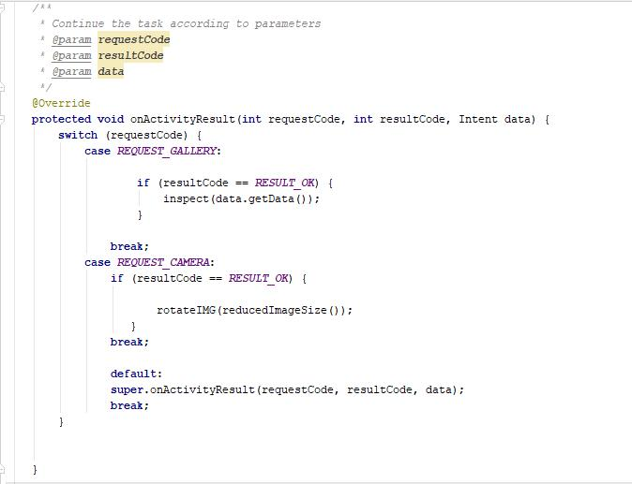

*Figure 26: Result handling*

* **Image processing**

Image quality should be high to increase text detection rate. And also image size will reduce to increase efficiency while converting it in to quality bitmap. Finally, particular Bitmap image send to correct the orientation of image. According to the EXIFINTERFACE library, the image rotates in to 0 degrees and correct the orientation of the image if it was wrong.



37 | P a g e

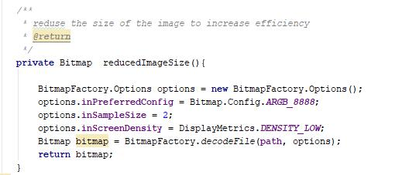

*Figure 27: process image to increase the quality*

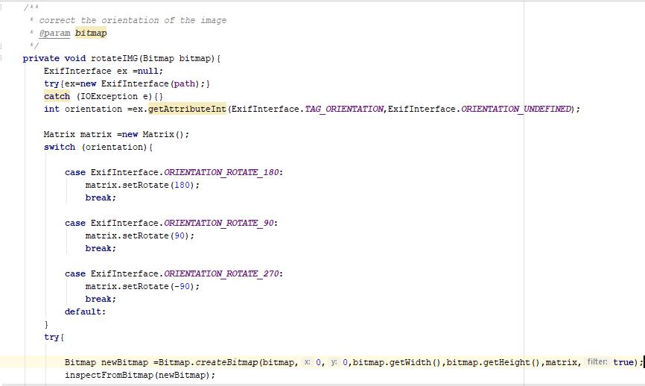

*Figure 28:Correct the image orientation*

* **Recognize text from an image**

After completion of image processing, the image will send to the recognize text. Before the recognize text, it will check the text recognizer operational or not. If it is operational, recognizer starts to extract text blocks from an image and add it in to an array. After that particular text blocks sorting in proper manner. Finally, recognized texts are appending



38 | P a g e

and final sentence set in to the text view. After completion of above process, recognizer will release. Following code segments will demonstrate the process of recognition.

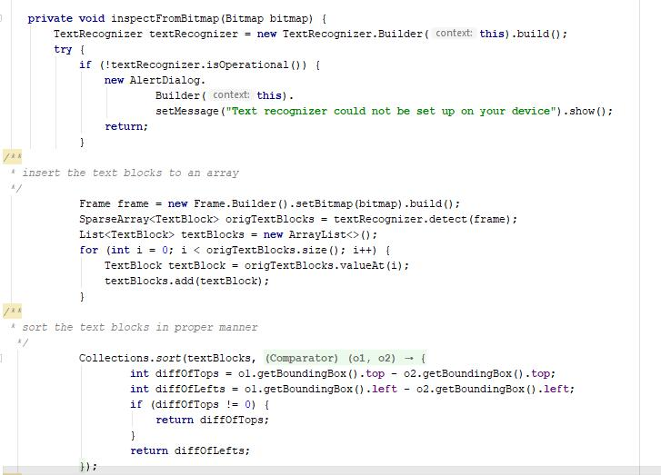

*Figure 29: Text recognition process*



39 | P a g e

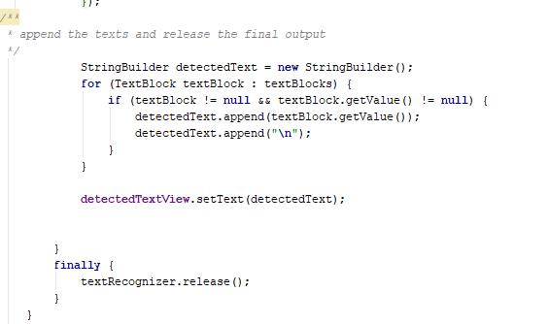

*Figure 30: Recognized text set in to text view*

**Version 2**

Version 2 released by introducing web search function to the user. With that function user able to detected text search on internet if user required additional information. Since no other OCR base application providing function to search on web, uniqueness of this application has been increased. By fixing bugs which has been occurred in version 1, effectiveness of the application has been increased.

* WEB search function.
* Unit tested.



40 | P a g e

**Implementation**

* **Web search**

Normally first sentence explains the gravity of entire paragraph. With that fact this application extracts the first sentence from detected text fields and it will send to

“goToWeb” method. Once the method called, the method will prepare the statement to search and start the activity web search. Following figures demonstrates the code of WEB search.

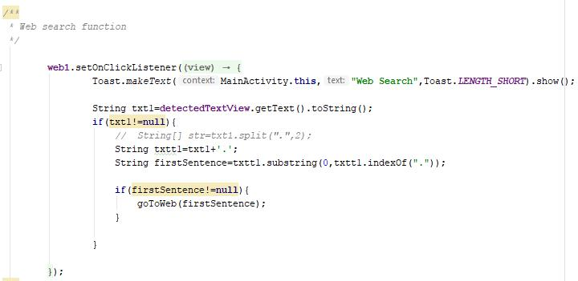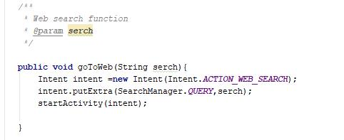

*Figure 31: Web search function*



41 | P a g e

**Version 3**

3rd version of this application has been released with introducing package of new feature to the users. In this version it has been introduced simple calculator to perform basic mathematic and Text to voice function. Moreover, for the users’ convenience it has been introduced function to speech to text also. With these new functions user able to perform basic calculations and hear output as voice. Likewise, this application offering more features to user’s convenience and according to the user feedbacks all bugs were fixed which has been occurred in previous versions.

* Perform basic calculations.
* Text to Voice.
* Speech to Text.
* Unit tested.

**Implementation**

* **Calculation**

As the first step of calculation, all white spaces are removing. To perform basic calculations, it has to be detect two numbers. So for that, this application uses simple trick. It is split the detected equation in to two by identifying special character. After identified mathematical symbol and the two numbers it will solving the equation according to identified mathematical symbol. Following figures clearly describe the process of calculation.



42 | P a g e

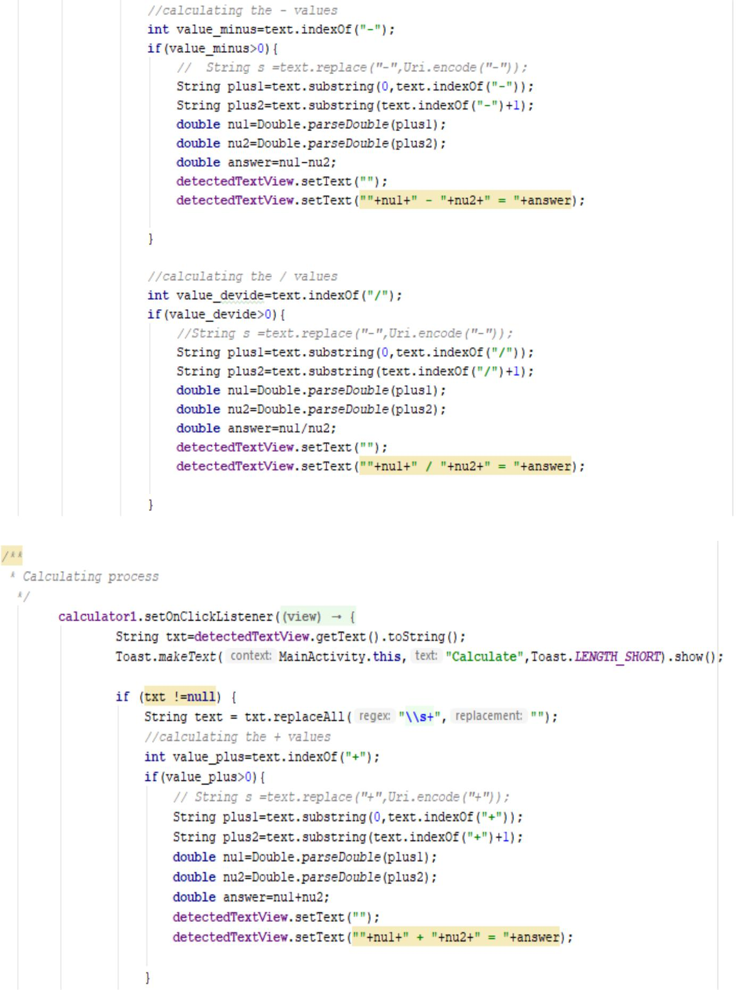

43 | P a g e

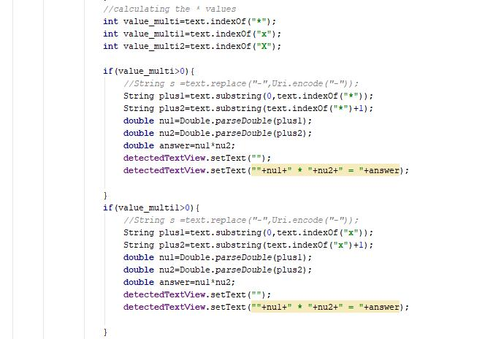

*Figure 32: Calculation process*

* **Text to voice**

Text to speech function work according to detected text view and as per the user request it will perform. Following code segment will demonstrate the process of text to speech function.



44 | P a g e

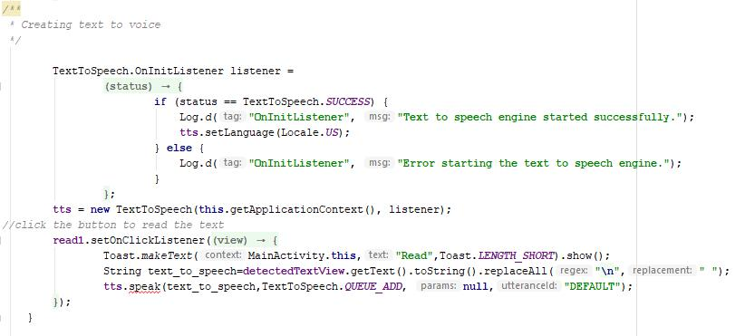

*Figure 33: Text to speech*

* **Speech to Text**

This function allows user to input the text via speech and it is very easy to visually impaired people to interact with the application. And also its efficiency is very higher than the typing text. Following code segment will demonstrate the implementation of the speech to text function.

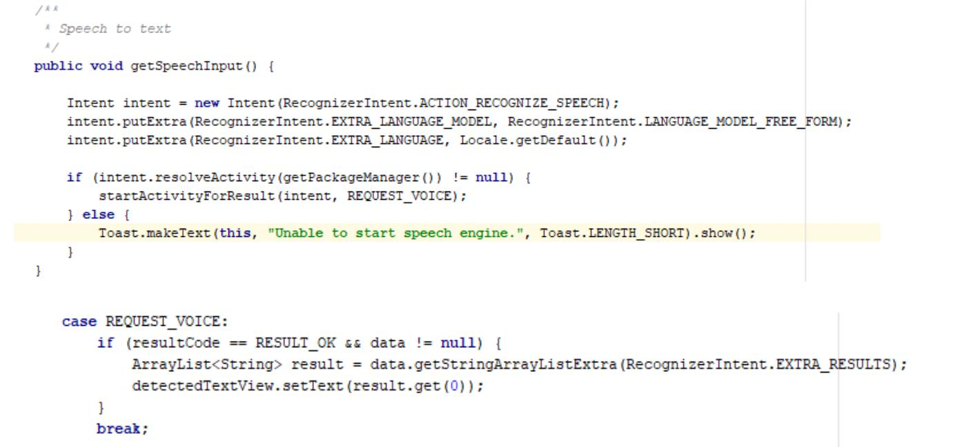

*Figure 34:Speech to text*



45 | P a g e

3.5 Testing

The system has been mainly tested under White box and usability testing methods. Before the release each version of this application, it has been tested under unit testing method to check whether all code segments and the functions work properly. According to the unit testing method each function of this application has been tested separately. Sometimes it was hard to locate errors/bugs when several functions were tested together. Code checking was depended on according to the result of particular function working or not. Once it completed, mainly focused to check the syntax errors such as invalid variable types, casting exceptions, illegal arguments and invalid parameters are belonging to syntax error checking criteria. Finally, the application tested under system testing method to verify the application meets its specified requirements. And also external interfaces, performance and the programming functionalities tested to increase the quality of this application.

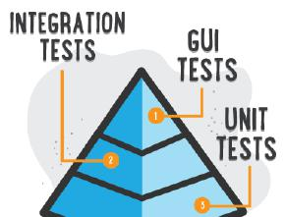

*Figure 35: Testing methods*



46 | P a g e

|  |  |  |  |
| --- | --- | --- | --- |
|  | Test Case ID | TC-001 |  |
|  |  |  |  |
|  | Test Description | Splash screen activity Starts with logo. |  |
|  |  |  |  |
|  | Test Procedure | Start the application |  |
|  |  |  |  |
|  | Input Values | - |  |
|  |  |  |  |
|  | Expected Result | Splash screen. |  |
|  |  |  |  |
|  | Actual Result | Same as expected |  |
|  |  |  |  |
|  | Status | Pass |  |
|  |  |  |  |
|  |  |  |  |
|  |  |  |  |

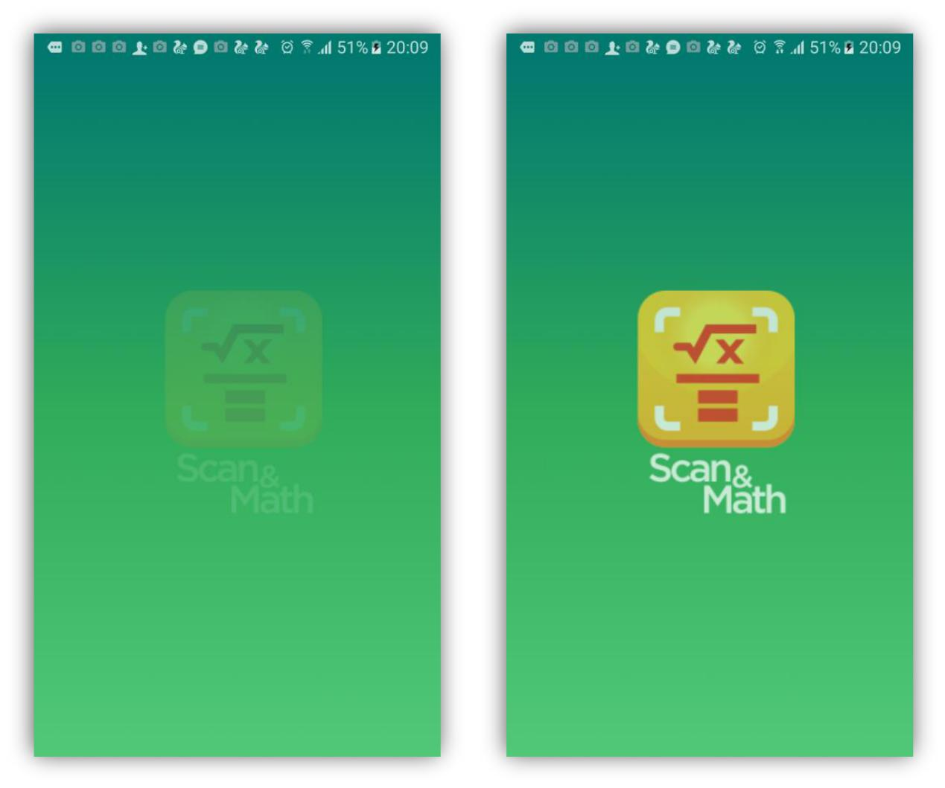

47 | P a g e

|  |  |  |  |
| --- | --- | --- | --- |
|  | Test Case ID | TC-002 |  |
|  |  |  |  |
|  | Test Description | Showing an error message when text |  |
|  |  | recognizer failed to setup |  |
|  |  |  |  |
|  | Test Procedure | Starting the application |  |
|  |  |  |  |
|  | Input Values | - |  |
|  |  |  |  |
|  | Expected Result | Display error message |  |
|  |  |  |  |
|  | Actual Result | Same as expected |  |
|  |  |  |  |
|  | Status | Pass |  |
|  |  |  |  |
|  |  |  |  |
|  |  |  |  |

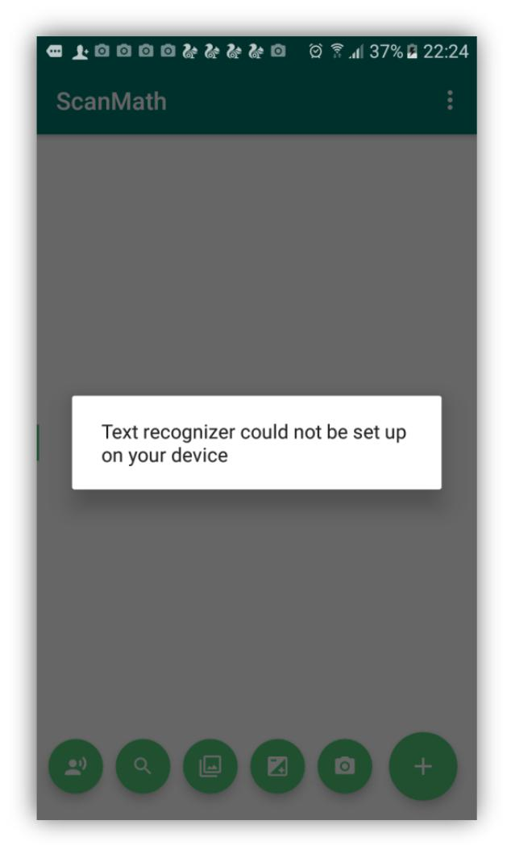

48 | P a g e

|  |  |  |  |
| --- | --- | --- | --- |
|  | Test Case ID | TC-003 |  |
|  |  |  |  |
|  | Test Description | All sub buttons will appeared when user |  |
|  |  | touches on the main floating button. |  |
|  |  |  |  |
|  | Test Procedure | Touch on the main floating button |  |
|  |  |  |  |
|  | Input Values | - |  |
|  |  |  |  |
|  | Expected Result | Appear the sub buttons |  |
|  |  |  |  |
|  | Actual Result | Same as expected |  |
|  |  |  |  |
|  | Status | Pass |  |
|  |  |  |  |
|  |  |  |  |
|  |  |  |  |

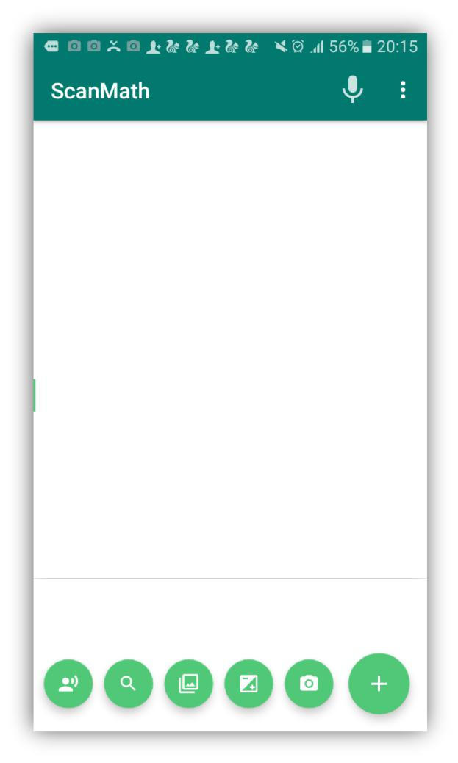

49 | P a g e

|  |  |  |  |
| --- | --- | --- | --- |
|  | Test Case ID | TC-004 |  |
|  |  |  |  |
|  | Test Description | All sub buttons will disappeared when user |  |
|  |  | touches on the main floating button. |  |
|  |  |  |  |
|  | Test Procedure | Touch on the main floating button |  |
|  |  |  |  |
|  | Input Values | - |  |
|  |  |  |  |
|  | Expected Result | Disappear the sub buttons |  |
|  |  |  |  |
|  | Actual Result | Same as expected |  |
|  |  |  |  |
|  | Status | Pass |  |
|  |  |  |  |
|  |  |  |  |
|  |  |  |  |

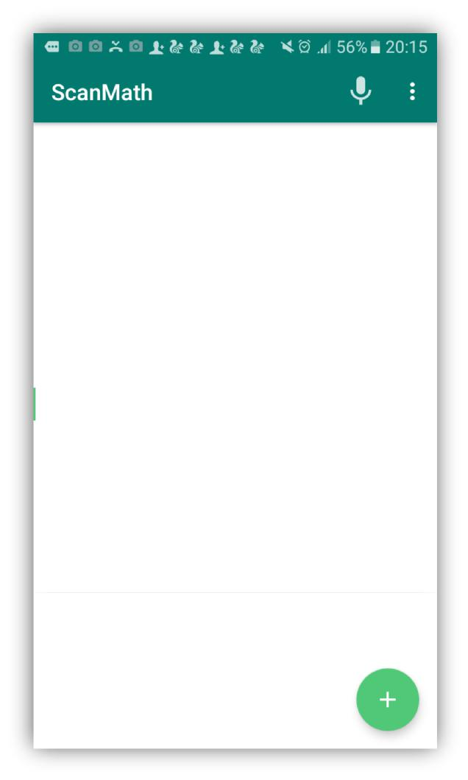

50 | P a g e

|  |  |  |  |
| --- | --- | --- | --- |
|  | Test Case ID | TC-005 |  |
|  |  |  |  |
|  | Test Description | Toast message will show once the user |  |
|  |  | touches on the button. |  |
|  |  |  |  |
|  | Test Procedure | Touch the button |  |
|  |  |  |  |
|  | Input Values | - |  |
|  |  |  |  |
|  | Expected Result | Show the toast message |  |
|  |  |  |  |
|  | Actual Result | Same as expected |  |
|  |  |  |  |
|  | Status | Pass |  |
|  |  |  |  |
|  |  |  |  |
|  |  |  |  |

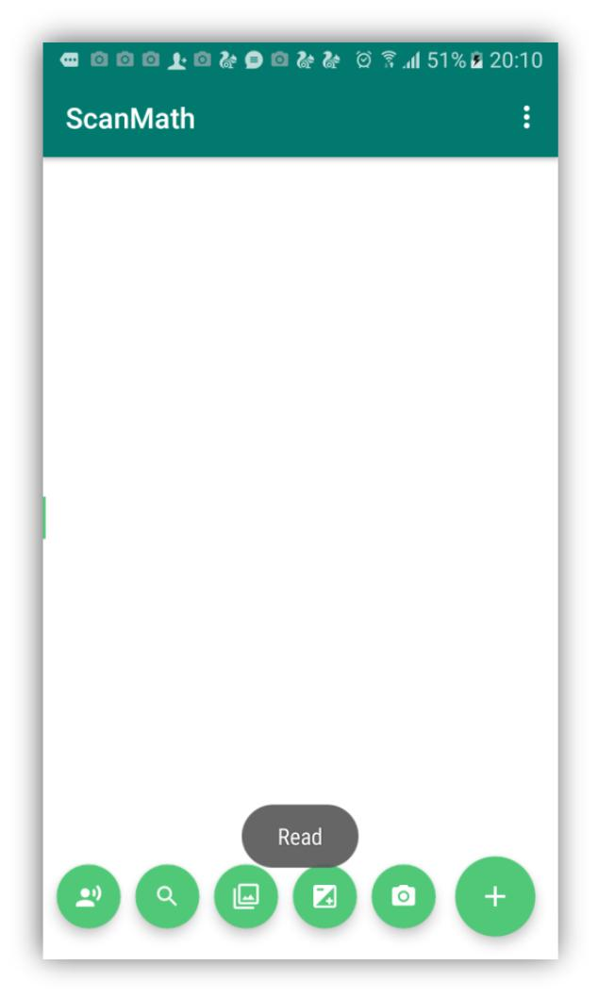

51 | P a g e

|  |  |  |  |
| --- | --- | --- | --- |
|  | Test Case ID | TC-006 |  |
|  |  |  |  |
|  | Test Description | Camera will turn on once user touches on |  |
|  |  | camera button. |  |
|  |  |  |  |
|  | Test Procedure | Touch the camera button |  |
|  |  |  |  |
|  | Input Values | - |  |
|  |  |  |  |
|  | Expected Result | Starting camera activity |  |
|  |  |  |  |
|  | Actual Result | Same as expected |  |
|  |  |  |  |
|  | Status | Pass |  |
|  |  |  |  |
|  |  |  |  |
|  |  |  |  |

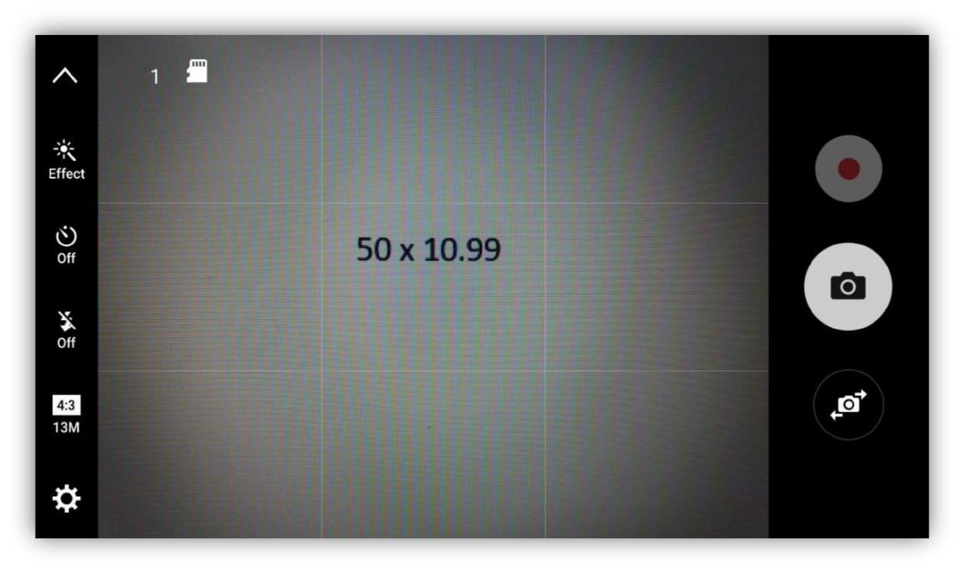

52 | P a g e

|  |  |  |  |  |
| --- | --- | --- | --- | --- |
|  | Test Case ID | TC-007 |  |  |
|  |  |  |  |  |
|  | Test Description | Once user capture the image it will asked to |  |  |
|  | retry or continue with captured image. |  |  |
|  |  |  |  |
|  |  |  |  |  |
|  | Test Procedure | Capture an image |  |  |
|  |  |  |  |  |
|  | Input Values | - |  |  |
|  |  |  |  |  |
|  | Expected Result | Ask to retry the process |  |  |
|  |  |  |  |  |
|  | Actual Result | Same as expected |  |  |
|  |  |  |  |  |
|  | Status | Pass |  |  |
|  |  |  |  |  |
|  |  |  |  |  |
|  |  |  |  |  |

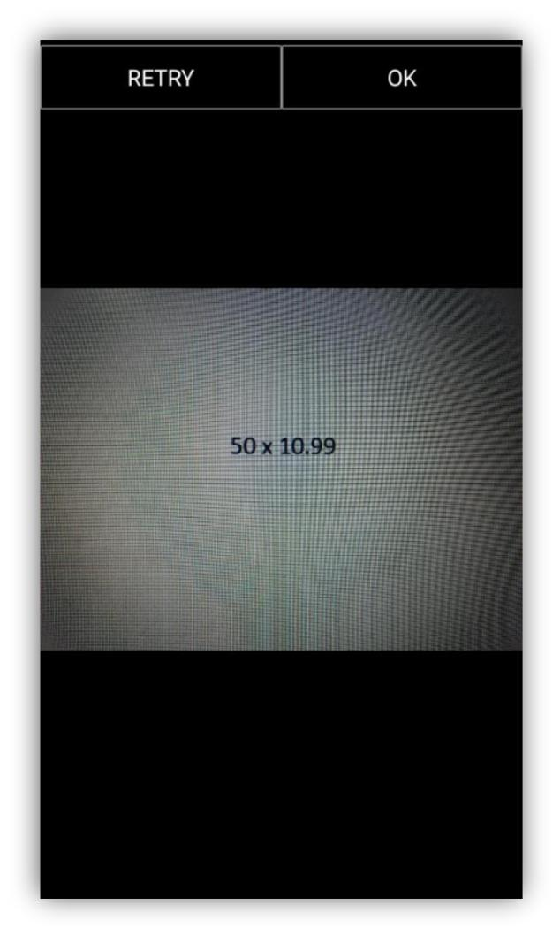

53 | P a g e

|  |  |  |  |
| --- | --- | --- | --- |
|  | Test Case ID | TC-008 |  |
|  |  |  |  |
|  | Test Description | Proceed to image gallery. |  |
|  |  |  |  |
|  | Test Procedure | Touch on gallery button |  |
|  |  |  |  |
|  | Input Values | - |  |
|  |  |  |  |
|  | Expected Result | Proceed to phone gallery |  |
|  |  |  |  |
|  | Actual Result | Same as expected |  |
|  |  |  |  |
|  | Status | Pass |  |
|  |  |  |  |
|  |  |  |  |
|  |  |  |  |

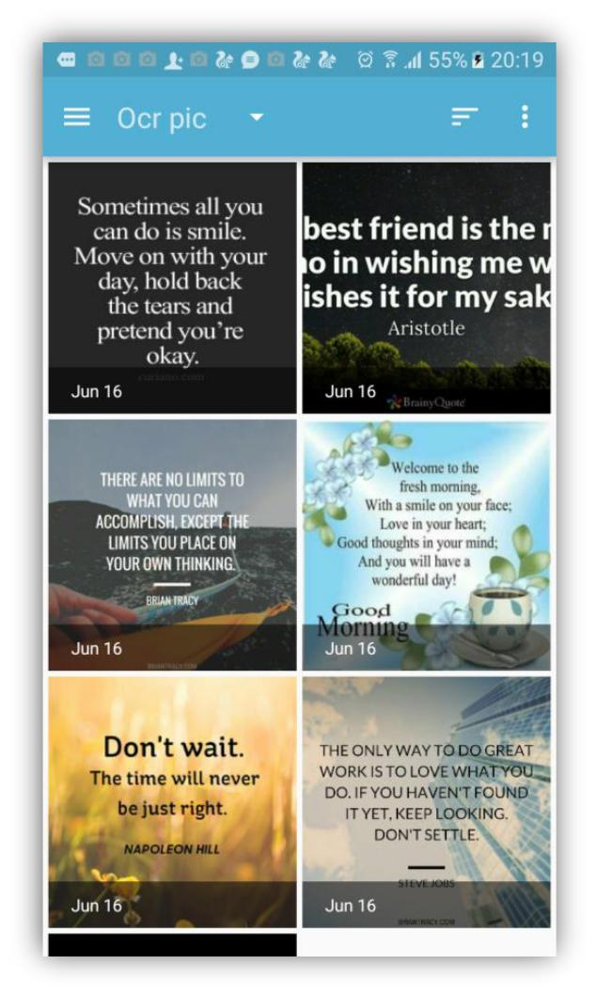

54 | P a g e

|  |  |  |  |
| --- | --- | --- | --- |
|  | Test Case ID | TC-009 |  |
|  |  |  |  |
|  | Test Description | Recognize the text from digital image. |  |
|  |  |  |  |
|  | Test Procedure | Capture or select image from gallery |  |
|  |  |  |  |
|  | Input Values | - |  |
|  |  |  |  |
|  | Expected Result | Show the recognized text on text view. |  |
|  |  |  |  |
|  | Actual Result | Same as expected |  |
|  |  |  |  |
|  | Status | Pass |  |
|  |  |  |  |
|  |  |  |  |
|  |  |  |  |

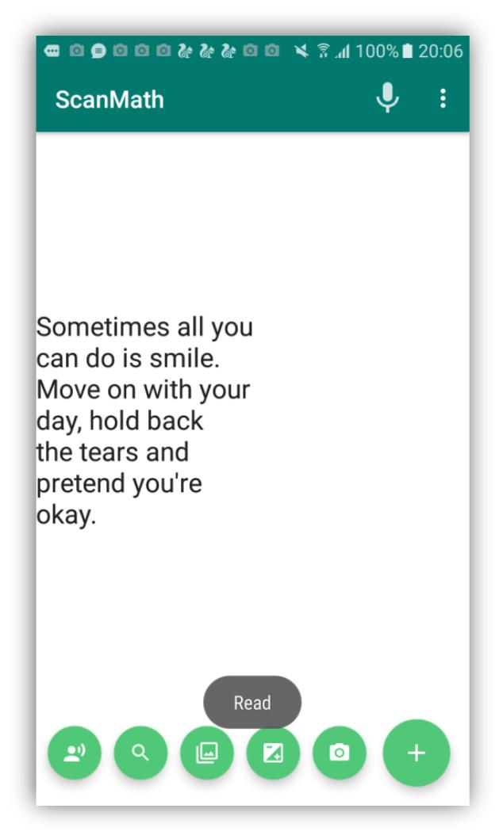

55 | P a g e

|  |  |  |  |
| --- | --- | --- | --- |
|  | Test Case ID | TC-010 |  |
|  |  |  |  |
|  | Test Description | Allow user to edit, copy and cut the |  |
|  |  | recognized text |  |
|  |  |  |  |
|  | Test Procedure | Recognize the text from image |  |
|  |  |  |  |
|  | Input Values | - |  |
|  |  |  |  |
|  | Expected Result | Suggest features to edit, copy, cut |  |
|  |  |  |  |
|  | Actual Result | Same as expected |  |
|  |  |  |  |
|  | Status | Pass |  |
|  |  |  |  |
|  |  |  |  |
|  |  |  |  |

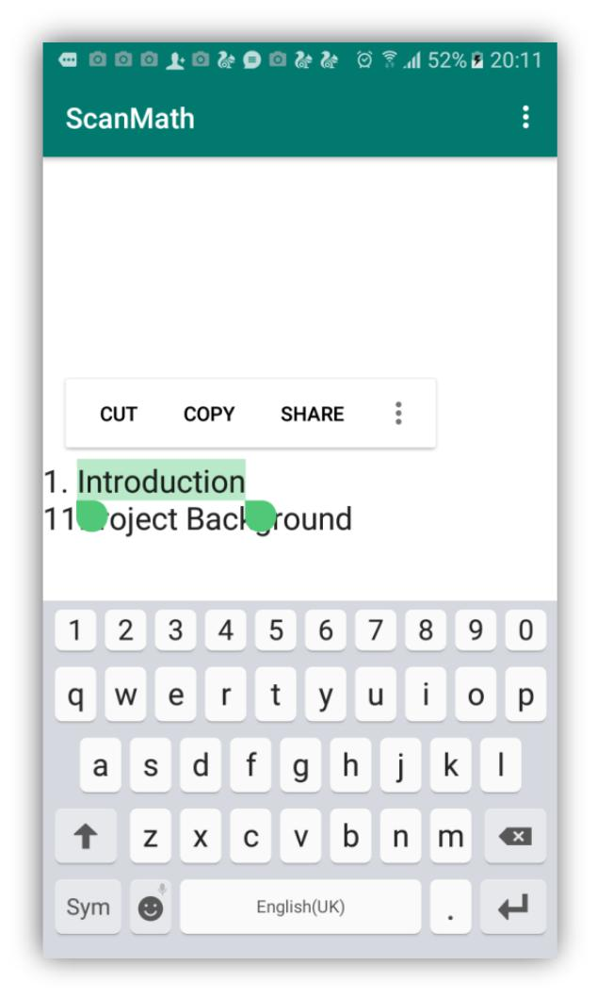

56 | P a g e

|  |  |  |  |
| --- | --- | --- | --- |
|  | Test Case ID | TC-011 |  |
|  |  |  |  |
|  | Test Description | User allow to translate the recognized text |  |
|  |  | through google translator.(This extra |  |
|  |  | feature enable only with google translator |  |
|  |  | installed devices) |  |
|  |  |  |  |
|  | Test Procedure | Select the text which user require to |  |
|  |  | translate |  |
|  |  |  |  |
|  | Expected Result | Show translated text |  |
|  |  |  |  |
|  | Actual Result | Same as expected |  |
|  |  |  |  |
|  | Status | Pass |  |
|  |  |  |  |
|  |  |  |  |
|  |  |  |  |

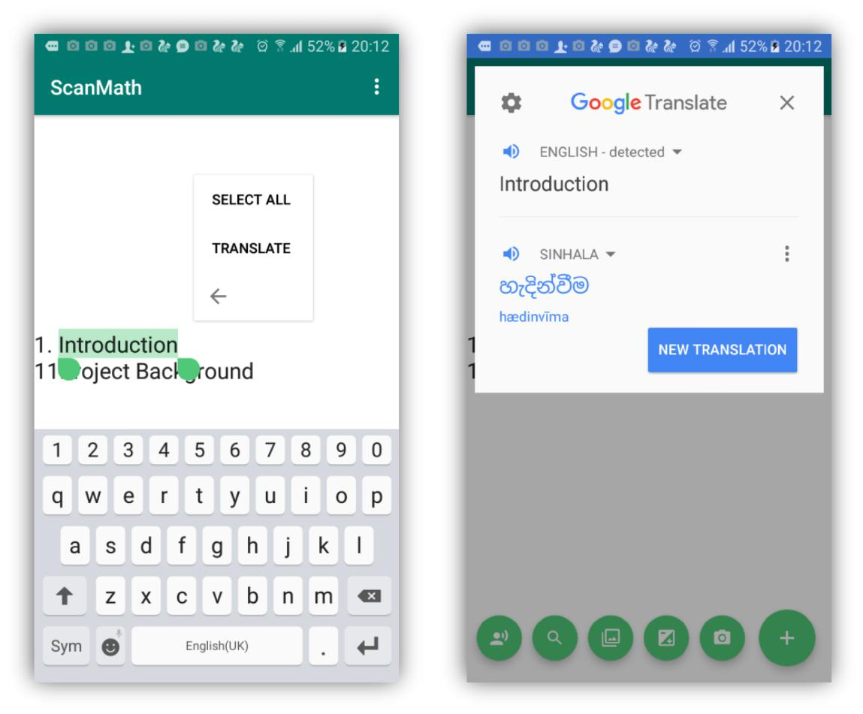

57 | P a g e

|  |  |  |  |
| --- | --- | --- | --- |
|  | Test Case ID | TC-012 |  |
|  |  |  |  |
|  | Test Description | Application process simple calculation. |  |
|  |  |  |  |
|  | Test Procedure | Capture the equation and touch the |  |
|  |  | calculate button |  |
|  |  |  |  |
|  | Input Values | - |  |
|  |  |  |  |
|  | Expected Result | Display results according to the equation. |  |
|  |  |  |  |
|  | Actual Result | Same as expected |  |
|  |  |  |  |
|  | Status | Pass |  |
|  |  |  |  |
|  |  |  |  |
|  |  |  |  |

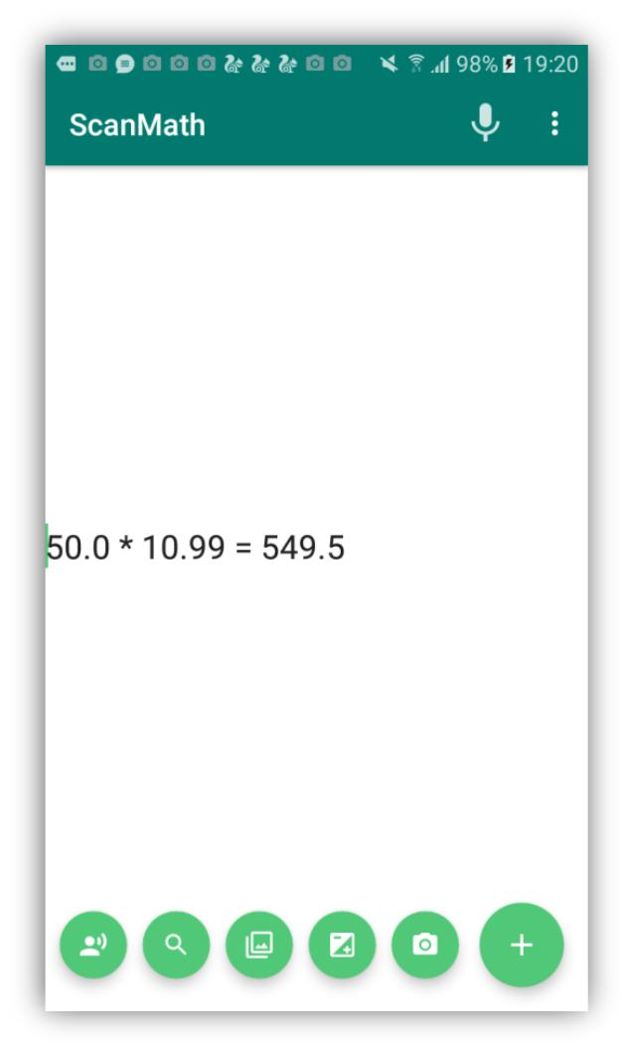

58 | P a g e

|  |  |  |  |
| --- | --- | --- | --- |
|  | Test Case ID | TC-013 |  |
|  |  |  |  |
|  | Test Description | Recognized text search on the web. |  |
|  |  |  |  |
|  | Test Procedure | Capture or select image from gallery |  |
|  |  |  |  |
|  | Input Values | - |  |
|  |  |  |  |
|  | Expected Result | Show searched results. |  |
|  |  |  |  |
|  | Actual Result | Same as expected |  |
|  |  |  |  |
|  | Status | Pass |  |
|  |  |  |  |
|  |  |  |  |
|  |  |  |  |

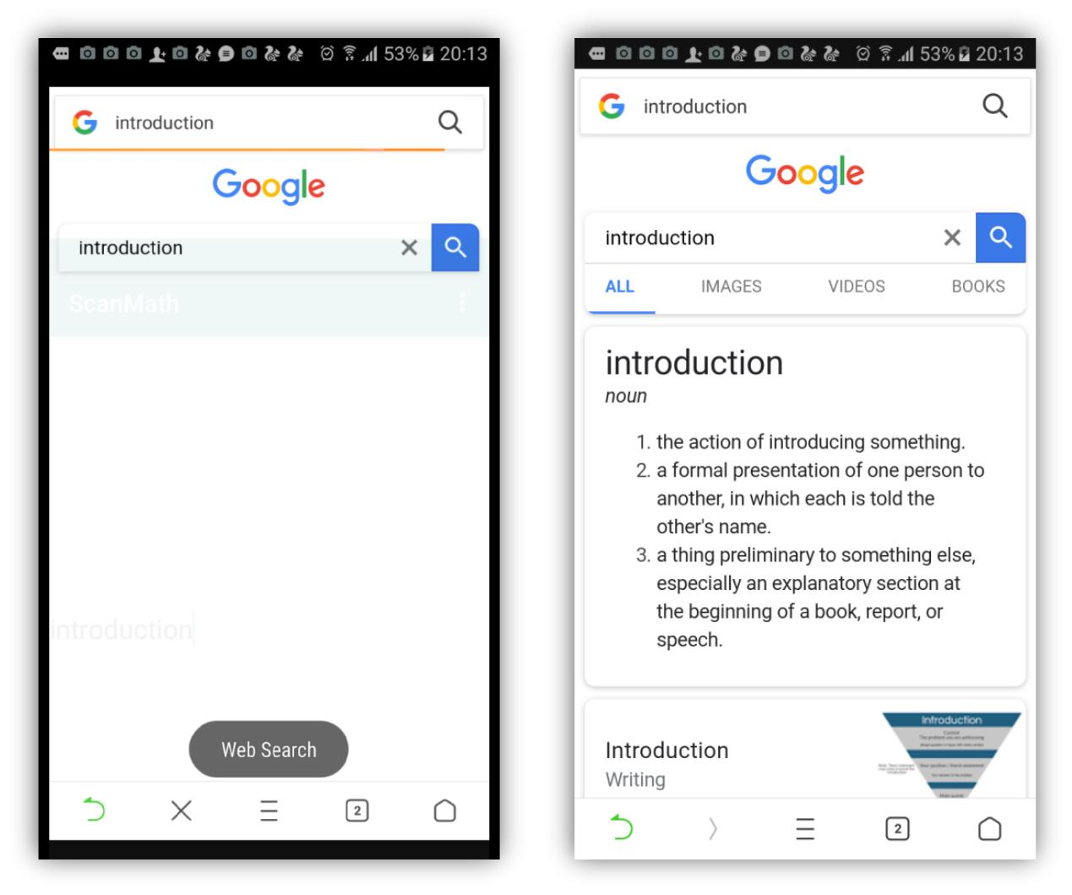

59 | P a g e

|  |  |  |  |
| --- | --- | --- | --- |
|  | Test Case ID | TC-014 |  |
|  |  |  |  |
|  | Test Description | Read the recognized text(Voice output). |  |
|  |  |  |  |
|  | Test Procedure | Capture or select image from gallery |  |
|  |  |  |  |
|  | Input Values | - |  |
|  |  |  |  |
|  | Expected Result | Voice output. |  |
|  |  |  |  |
|  | Actual Result | Same as expected |  |
|  |  |  |  |
|  | Status | Pass |  |
|  |  |  |  |
|  |  |  |  |
|  |  |  |  |



60 | P a g e

|  |  |  |  |
| --- | --- | --- | --- |
|  | Test Case ID | TC-015 |  |
|  |  |  |  |
|  | Test Description | Voice input shown as the text output in |  |
|  |  | editable way |  |
|  |  |  |  |
|  | Test Procedure | Once user click the mic button user will able |  |
|  |  | to give voice input |  |
|  |  |  |  |
|  | Input Values | Voice input |  |
|  |  |  |  |
|  | Expected Result | Text output. |  |
|  |  |  |  |
|  | Actual Result | Same as expected |  |
|  |  |  |  |
|  | Status | Pass |  |
|  |  |  |  |
|  |  |  |  |
|  |  |  |  |

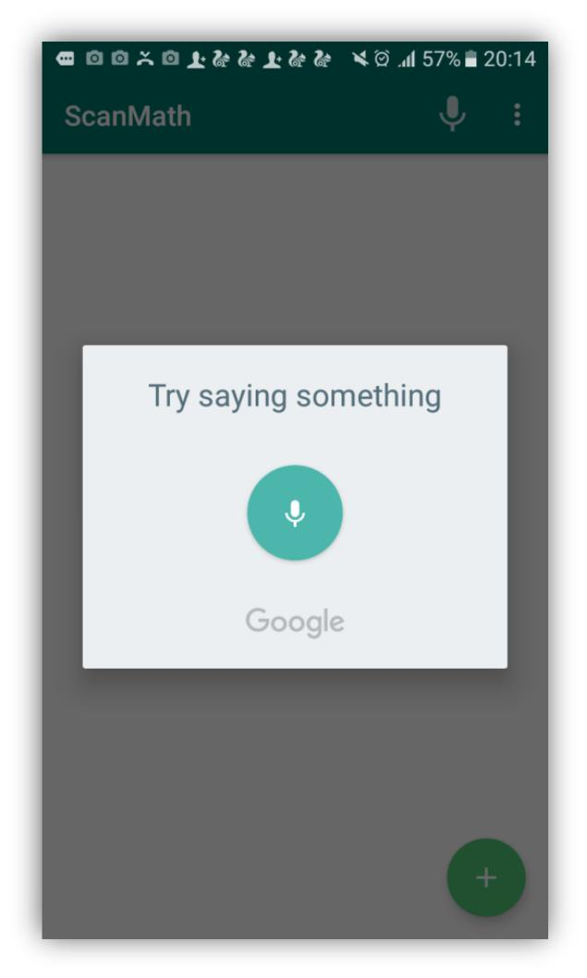

61 | P a g e

3.6 Evaluation

The evaluation of this application has been don according to the feedbacks reported by group of actual users. The group consist of SLIIT Computing students and some of family members. Age range of 20 years to 70 years old people were selected as group members. Fully developed final product has been distributed among them to evaluate the application. To collect the feedbacks of the users it has been created a feedback document. The evaluation document has been attached with Appendix B. According to the user feedbacks, most of the users were happy with the interfaces of the application. They were attractive, user friendly and will not overwhelming fresh users. Most of the people were like the calculating function. According to their opinion that function save their time and it always performing fast results with high accuracy. With the text to speech(Reading) function they won’t spend time on reading articles with small letters. The application read the article behalf of the user. Web search function was the most attractive function among the users. According to their feedbacks, they were able to search anything on google without typing. It was a great function all the time. Finally, all group of users were really happy with this system because of it providing package of features together since any other OCR base application doesn’t provide.

According to the nature there were some bad feedbacks also by highlighting areas which has to be improve in the system. Calculating function made some users unhappy since it unable to solve long equations such as (4+5-2), (50*800+4) etc. And most of the people made negative feedbacks since the application unable to capture selected area by targeting single text or equation. Most of the users unhappy with that issue. And also some of them were complaint that the detected



62 | P a g e

word and the actual word differ sometimes. Likewise, there were some areas which make user unhappy and need to be improve.

Following figure describe the performances of the application base on the actual user’s feedbacks;

|  |  |  |  |  |
| --- | --- | --- | --- | --- |
| **Function** | Excellent | Good | Average | Bad |
|  |  |  |  |  |
| Calculation | **✓** |  |  |  |
|  |  |  |  |  |
| Web search | **✓** |  |  |  |
|  |  |  |  |  |
| Voice to text |  | **✓** |  |  |
|  |  |  |  |  |
| Text detection |  | **✓** |  |  |
|  |  |  |  |  |
| Text to speech | **✓** |  |  |  |
|  |  |  |  |  |
| Interfaces and the | **✓** |  |  |  |
| appearance |  |  |  |  |
|  |  |  |  |  |
|  | *Figure 36:Performences of the application* | |  |  |



63 | P a g e

Here are some comments given by the actual Users according to their experience with the

Scan&Math application.

|  |  |
| --- | --- |
| **No.** | **Comment** |
|  |  |
| 01. | Perfect and invaluable tool for those of us who get overwhelmed by large blocks of |
|  | text |
|  |  |
| 02. | The app is great but it would be better if you add a feature that the scanner should |
|  | detect the hand written equations. However, it is still helpful and hope for development |
|  | on my suggestion. |
|  |  |
| 03. | Best app ever for converting images into text. Tremendously useful for teachers, |
|  | students and visually impaired people. Loved it. |
|  |  |
| 04. | Some Words recognize Wrongly. But it's ok. At least, it's quite better comparison to |
|  | other similar apps. Thanks |
|  |  |
| 05. | This app is awesome! It was really useful and besides from the camera that could solve |
|  | any problem, it also had a regular calculator function and ability. Great work! |
|  |  |
| 06. | it's effective application but It will make a few mistakes depending on text font and |
|  | image quality, but still fantastic. |
|  |  |
| 07. | Application is offering attractive bundle of features. Web search function is my |
|  | favorite. |

1. Really useful... Just as good as a physical calculator. Solving equations with camera would help a lot
   1. The interfaces of this application is user friendly and easy to use. appearance also

nice. Great job.

*Figure 37: Comments given by the users*



64 | P a g e

Chapter 04: Results and Discussions

* **Accuracy and the performance**

“Scan&Math” is mainly focuses to help visually impaired people and the other people also can beneficial through this application in their day-to-day tasks. Since the application uses the latest OCR libraries, the accuracy and the performance are very high. To increase the accuracy of this application image quality has been increased by using suitable image processing techniques. URI (Uniform Resource Identifier) has been used to identify correct path of the image. Because URI is a string which refers directly to the resource.

Always high performance and the effectiveness are the key features of a quality product. With that fact, the interfaces of this product were designed user friendly and easy to use manner to increase user performance through this application. And also image size was reduced before the process. Because process time will depend on size of the image. Therefore, images with small sizes are process fast than the large size of images and that process time will directly affect to the performance of the application. Furthermore, it has been used URI to find location of the image file and it is very fast method than searching file through its path. Likewise, this application used so many strategies to increase performance and the accuracy of the system.

* **Technical problems**

Technical problems are the most common problems which occurs during the software life time. Since the project mainly focuses visually impaired people and had to concern their needs and the daily tasks. When it comes to the development process of the project, initially gathered requirements were insufficient. So it has to gather requirement data



65 | P a g e

again. If the requirements were not good, project will fail and people will hate the result. With that fact conduct another few interviews to gather complete and correct requirements.

Bugs-free software does not exist in the world. As the above statement, when it comes to the testing phase there was an error in orientation of the image. The images capture through OCR camera were always process with incorrect orientation. Therefore, its unable to detect text from the captured images. To overcome from this problem, it has been used EXIFINTERFACE library. And with that library it was able to correct the orientation of the captured image. It cost more time to overcome with the issue and project time plan was deviated. To balance with project time plan, step by step reduce the extra time which allocated to implementation of small functions. With that solution it was able to balance with the project time plan and finish the project before the dead line.

Chapter 05: Conclusion

5.1 Benefits

“Scan&Math” is a product which is developed to help visually impaired people in their daily tasks. But with the performance and the accuracy, all other people also can beneficial from this application. Basically this application scans the text from the digital image and process it in to editable text. Therefore, user able to edit the text and copy past it as the user’s requirement. And also if user required additional information about the scanned text, user able to simply search it on the web through this application. With the use of Scan & Math the user able to work out



66 | P a g e

simple arithmetic problems by capturing an image of the specific equation. Furthermore, application able to give voice output of all scanned texts and the answers which solve by the calculate function. Likewise, it offering package of functions and beneficial for all Scan&Math users.

5.2 Limitations

Currently this application developed to solve simple mathematical equations only. It cannot solve long equations with multiple arithmetic symbols. As discussed in evaluation chapter this feature was a missed part of this application. And also it is unable to capture customized area by targeting single text or the equation. It is one of the main defect of this application and most of the user suggest to add this feature in future. Likewise, these are the main limitations of this application and according to the user feedbacks these functions are willing to develop in future.

5.3 Summery

This is the final thesis report of “Scan&Math” android based application. The report mainly consists of 5 chapters and each chapter described the background processes of the “Scan& Math” application such as project background, requirement gathering and analyzing, design of the project, testing and last evaluation of the project. Moreover, it will provide a detail discussion about the project by highlighting performance, accuracy and the technical problems. As the commencing stage, there were identified 3 main objectives according to fulfill the aim of the project and by successfully achieving each one of them completed the entire project. Even through in some versions failed to complete entire function within the allocated time according to GANTT chart because of some problem occurred and have to overcome with them. But at the



67 | P a g e

end, it has been successfully developed the entire project and evaluate it before the deadline. There were some problems occurred in the development process and manage to overcome with them by following proper testing and coding standards. Likewise, the final result of the project “Scan&Math” will beneficial for the visually impaired people and all other people.

5.5 Feature works

In the future, this application will upload to the google play store and people can beneficial by using this application. And also there is a possibility to release new version by adding fabulous features to the current system. With that fact it is supposed to add modifications such as detect hand written texts, procedure to solve long equations with multiple arithmetic symbols and adding a feature to capture customized area by the user. Likewise, with these features user will able to be more beneficial than the current system.

References

Anandhi, N. and Avudaiammal, R., 2017, April. Segmentation and recognition of text from image using pattern matching. In *Communication and Signal Processing (ICCSP), 2017 International* *Conference on* (pp. 0066-0069). IEEE.

Arik, S.O., Chrzanowski, M., Coates, A., Diamos, G., Gibiansky, A., Kang, Y., Li, X., Miller, J., Raiman, J., Sengupta, S. and Shoeybi, M., 2017. Deep voice: Real-time neural text-to-speech. *arXiv* *preprint arXiv:1702.07825*.



68 | P a g e

Boehm, B.W., 1988. A spiral model of software development and enhancement. *Computer*, *21*(5), pp.61-72.

Brisinello, M., Grbić, R., Pul, M. and Anđelić, T., 2017, September. Improving optical character recognition performance for low quality images. In *ELMAR, 2017 International Symposium* (pp. 167-171). IEEE.

Chandarana, J. and Kapadia, M., 2014. Optical character recognition. *International Journal of* *Emerging Technology and Advanced Engineering*, *4*(5), pp.219-223.

Chandio, A.A., Pickering, M. and Shafi, K., 2018, March. Character classification and recognition for Urdu texts in natural scene images. In *Computing, Mathematics and Engineering Technologies* *(iCoMET), 2018 International Conference on* (pp. 1-6). IEEE.

Du, S., Ibrahim, M., Shehata, M. and Badawy, W., 2013. Automatic license plate recognition (ALPR): A state-of-the-art review. *IEEE Transactions on circuits and systems for video* *technology*, *23*(2), pp.311-325.



69 | P a g e

Fleizach, C.B. and Hudson, R.D., Apple Inc, 2015. *Intelligent text-to-speech conversion*. U.S. Patent 8,996,376.

Hamadneh, I.M. and Al-Masaeed, A., 2015. Math teachers' attitudes towards photo math application in solving mathematical problem using mobile camera. *Educational Research and* *Reviews*, *10*(14), p.1930.

Jaderberg, M., Simonyan, K., Vedaldi, A. and Zisserman, A., 2014. Synthetic data and artificial neural networks for natural scene text recognition. *arXiv preprint arXiv:1406.2227*.

Kakani, B.V., Gandhi, D. and Jani, S., 2017, July. Improved OCR based automatic vehicle number plate recognition using features trained neural network. In *2017 8th International Conference on* *Computing, Communication and Networking Technologies (ICCCNT)* (pp. 1-6). IEEE.

Manwatkar, P.M. and Yadav, S.H., 2015, March. Text recognition from images. In *Innovations in* *Information, Embedded and Communication Systems (ICIIECS), 2015 International Conference on* (pp. 1-6). IEEE.



70 | P a g e

Netzer, Y., Wang, T., Coates, A., Bissacco, A., Wu, B. and Ng, A.Y., 2011, December. Reading digits in natural images with unsupervised feature learning. In *NIPS workshop on deep learning and* *unsupervised feature learning* (Vol. 2011, No. 2, p. 5)

Ochkov, V.F. and Bogomolova, E.P., 2015. Teaching mathematics with mathematical software. *Journal of Humanistic Mathematics*, *5*(1), pp.265-285.

O'malley, S., O'malley, M.H. and Peters, E., Berkeley Speech Tech Inc, 1991. *Text-to-speech* *converter of a facsimile graphic image*. U.S. Patent 4,996,707

Pang, L., Lan, Y., Guo, J., Xu, J., Wan, S. and Cheng, X., 2016, February. Text Matching as Image Recognition. In *AAAI*(pp. 2793-2799).

Pradeepa, K. and Sivitha, M., 2014, December. Optical persona realization of tantrum text sensing, excavation and recognition. In *Computational Intelligence and Computing Research* *(ICCIC), 2014 IEEE International Conference on*(pp. 1-4). IEEE.



71 | P a g e

Pranoto, Y.M., Setyati, E., Pramana, E., Kristian, Y. and Budiman, R., 2016, July. Real time handwriting recognition for mathematic expressions using Hidden Markov Model. In *Intelligent* *Technology and Its Applications (ISITIA), 2016 International Seminar on* (pp. 1-6). IEEE.

Shastry, S., Gunasheela, G., Dutt, T., Vinay, D.S. and Rupanagudi, S.R., 2013, March. “i”—A novel algorithm for optical character recognition (OCR). In *Automation, Computing, Communication,* *Control and Compressed Sensing (iMac4s), 2013 International Multi-Conference on* (pp. 389-393).IEEE.

Song, H., Kalasapur, S., Jeong, S. and Cheng, D., 2009, January. Smartsearch: Situation-aware web search on mobile devices. In *Consumer Communications and Networking Conference, 2009. CCNC* *2009. 6th IEEE* (pp. 1-2). IEEE.

Sonka, M., Hlavac, V. and Boyle, R., 2014. *Image processing, analysis, and machine vision*.

Cengage Learning.

Taylor, P., 2009. *Text-to-speech synthesis*. Cambridge university press.



72 | P a g e

Verma, A., Arora, S. and Verma, P., 2016. OCR Optical Character Recognition. In *7th International* *Conference on Recent Innovations in Science, Engineering and Management*.

World Health Organization. (2018). *Vision impairment and blindness*. [online] Available at: http://www.who.int/news-room/fact-sheets/detail/blindness-and-visual-impairment [Accessed 11 Sep. 2018].

Ye, Q. and Doermann, D., 2015. Text detection and recognition in imagery: A survey. *IEEE* *transactions on pattern analysis and machine intelligence*, *37*(7), pp.1480-1500.

Yin, X.C., Yin, X., Huang, K. and Hao, H.W., 2014. Robust text detection in natural scene images. *IEEE transactions on pattern analysis and machine intelligence*, *36*(5), pp.970-983.

Zhang, Y.Q., Ding, Y., Xiao, J.S., Liu, J. and Guo, Z., 2012. Visibility enhancement using an image filtering approach. *EURASIP Journal on Advances in Signal Processing*, *2012*(1), p.220.



73 | P a g e

Appendix A - Interview Questions

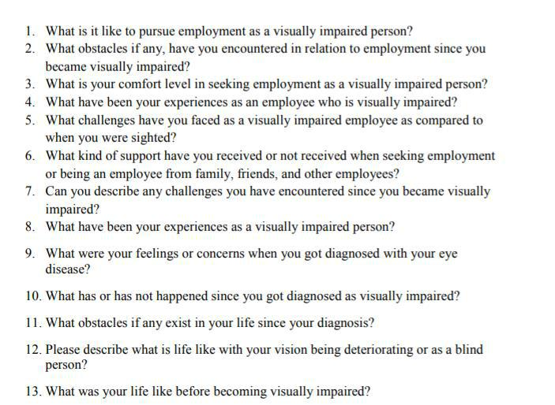

*Figure 38: Interview questions*



74 | P a g e

Appendix B - Evaluation form

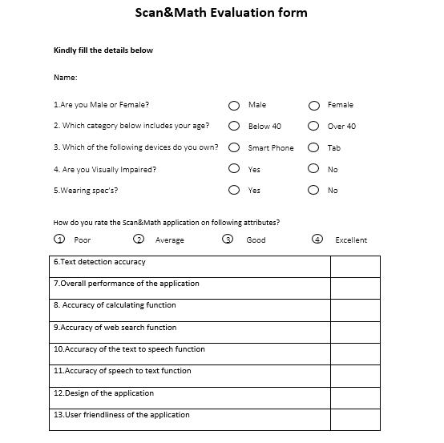

*Figure 39: Evaluation form part 1*



75 | P a g e

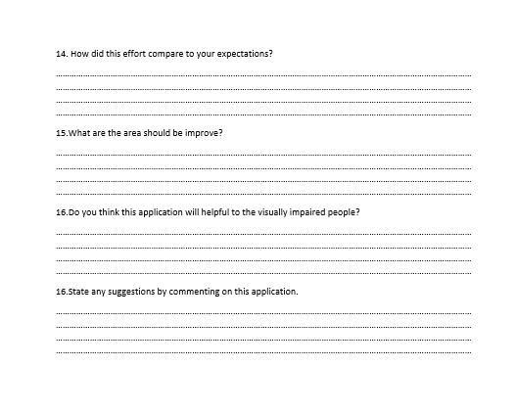

*Figure 40: Evaluation form part 2*



76 | P a g e

Appendix C - Poster

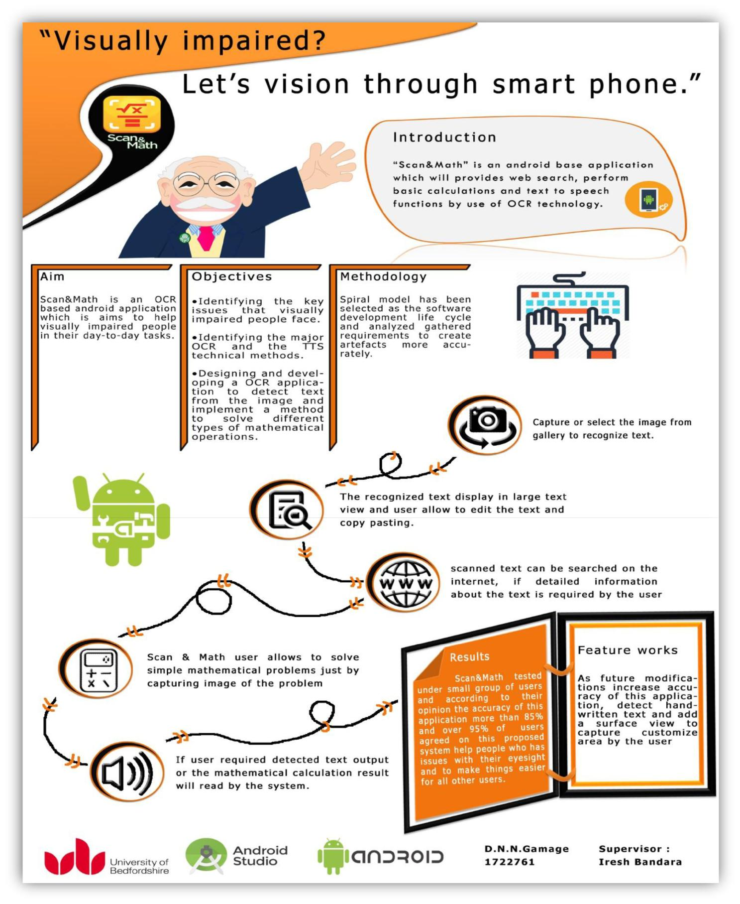

*Figure 41: Poster*



77 | P a g e